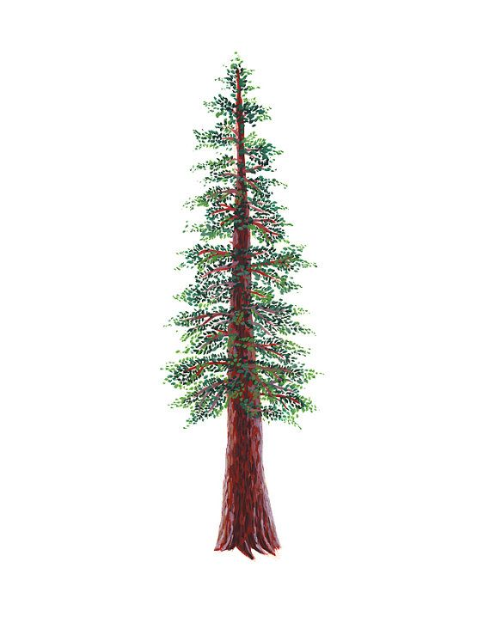

NORTH BAY LEAGUE GIRLS REDWOOD DIVISION ALL-LEAGUE, 2021

PLAYER OF THE YEAR

FIRST NAME | LAST NAME | GRADE | SCHOOL
Trix | Holstine | 12 | Ukiah

FIRST TEAM SINGLES (4)

FIRST NAME | LAST NAME | GRADE | SCHOOL
Elise | Martinez | 12 | Ukiah
Maritza | Jacobs | 10 | Ukiah
Indica | Carroll | 12 | Healdsburg
Izze | Smith | 10 | Healdsburg

FIRST TEAM DOUBLES (5)

FIRST NAME | LAST NAME | GRADE | SCHOOL
Angelina | Losak | 12 | Ukiah
Emily | Naja-Ramirez | 12 | Ukiah
Ryilie | Barber | 12 | Ukiah
Madeline | Armstrong | 11 | Ukiah
Yamileth | Arana | 12 | Healdsburg
Nancy | Avila | 12 | Healdsburg
Jenn | Rosillo | 12 | Healdsburg
Citlaly | Garcia | 12 | Healdsburg
Noor | Hinawi | 11 | Rancho Cotate
Mikayla | Vinluan | 10 | Rancho Cotate

