 | NORTH BAY LEAGUE  Joe Ellwood, Commissioner  jellwood@wscuhsd.org ; (707) 484-8410  Dean Haskins, Commissioner  dhaskins@srcs.k12.ca.us; (707) 484-0271 | 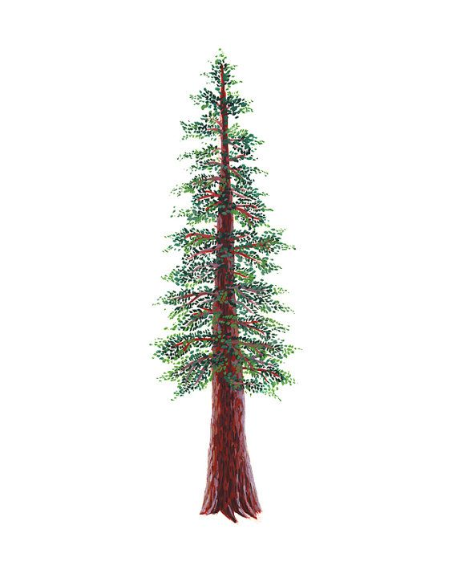
PRINCIPALS MEETING AGENDA
MONDAY, MAY 22, 2023
SANTA ROSA HIGH SCHOOL, 3:00 PM
Shauna Ferdinandson P | Analy | Mike Roan | Analy
Nicholas Reynolds | Cardinal Newman | Monica Mertle P | Cardinal Newman
Graham Rutherford P | Cardinal Newman | Ry Basham-Mintz | Elsie Allen
Gabe Albavera P | Elsie Allen | Josh Cavanagh | Healdsburg
Amy Jones | Healdsburg | Jerry Deakins | Maria Carrillo
Francisco Manriquez P | Healdsburg | Ryan Riddle P | Piner
Randy Burbank P | Maria Carrillo | Scotty McKeon | Rancho Cotate
Monique Luke | Maria Carrillo | Kenny Knowlton | Santa Rosa
Tyler Alborn P | Montgomery | Bryan Price | Santa Rosa
Andrea Correia P | Piner | Heather Campbell | St. Vincent
Henri Sarlatte P | Rancho Cotate | Stephen Summers P | Ukiah
Kimberly Clissold P | Santa Rosa | Jamie Williams P | Windsor
Patrick Daly P | St. Vincent
Gordon Oslund P | Ukiah | Joe Ellwood P | Commissioner
Brian Williams P | Windsor | Dean Haskins P | Commissioner
P = Present

I. | CALL TO ORDER AND ROLL CALL
II. | APPROVAL OF THE AGENDA ACTION (DH)
 | Motion to approve the meeting agenda.
 | Santa Rosa/Ukiah 12-0 passed
III. | APPROVAL OF THE NBL CONSENT AGENDA ACTION (DH)
Motion to approve the consent agenda.
Rancho Cotate/Ukiah 12-0 passed
 | - Volleyball Bylaw 13.102, 13.302
 | - Baseball/Softball pregame batting Bylaw 2.203,9.306
IV. | APPROVAL OF THE PREVIOUS MEETING MINUTES ACTION (DH)
Motion to approve meeting minutes from the 4/6/23 Principal’s meeting at Rancho Cotate HS
Ukiah/Montgomery 12-0 passed
V. | PUBLIC COMMENT
 | Pursuant to Education Code Section 54954.3 and Education Code Section 33353, any member of the public wishing to speak on any matter within the subject matter jurisdiction of the NBL, CIF, and NCS will be heard at this time. The time for such comment is no more than two (2) minutes per person on an item and no more than twenty (20) minutes total on an item or as designated by the Chair.
VI. | NORTH BAY LEAGUE AGENDA ITEMS
 | A. | PRESIDENT/PAST PRESIDENT/PRESIDENT-ELECT 23-24,24-25 ACTION (JE)
 |  | Motion to approve Gabe Albravera, Elsie Allen as the NBL President (2-year term) and the Healdsburg Principal/AP as the NBL President-Elect and Graham Rutherford, Cardinal Newman as Past-President
 |  | Ukiah/Maria Carrillo 12-0 passed
 | B. | NBL GOVERNANCE SCHEDULE, 2023 – 2024 ACTION (JE)
 |  | Motion to approve the Governance Schedule for 2023-2024 (attached)
 |  | Windsor/Ukiah 12-0 passed
 | C. | Proposed NBL Bylaw Amendments CONSENT
 |  | 1. | Volleyball Bylaw 13.102,13.302
 |  |  | 13.102 Girls’ Volleyball will be played in the fall season of sport and Boys’ Volleyball will be played in the spring season of sport. League matches will be played on Tuesday and Thursday.
 |  |  | 13.302 Addition of Single Varsity matches will start at 5 PM
 |  | 2. | 2.203,9.306 Teams will not be allowed to take batting practice or use pitching machines or batting cages at the game site within two hours of the scheduled game time. The use of regulation, whiffle, or other low flight balls may be used for hitting warm-up drills (provided it is allowed by the host facility), with the following exception: regulation balls may not be used for front toss. ONLY whiffle or other low flight balls may be used for front toss.  PENALTY FOR VIOLATION: The game shall be forfeited by the offending team.
 | D. | Commissioner/Asst. Commissioner reorganization ACTION (JE/DH)
 |  |  | Motion to approve reverting back to a Commissioner/Asst. Commissioner organizational format and salary adjustment.
 |  | 1. | Format  Joe Ellwood, Commissioner, and Dean Haskins, Asst. Commissioner
 |  | 2. | Salary  - Salary Adjustments
 |  | 3. | Duties  - Adjust Constitution as needed
Principal Oslund commended the current commissioners and voiced his support for the change in organizational format and a $3000 increase in the Commissioners' salary and a $3000 decrease in the Asst. Commissioner’s salary.
Ukiah/Montgomery 12-0 passed
 | E. | BUDGET AND DUES INFORMATION (JE)
 |  | 1. | Currently available money
- Wells Fargo Checking, $18,000 (approx)
- + NBL Spring Tournament Revenue (Estimated)
  - Track ($6000)
  - Swimming ($3000)
  - Baseball ($5000)
- Community First Credit Union 2 CDs
 |  | 2. | Upcoming expenses
- Salaries through June 30
- League passes for 2023-2024
- Medals for 2023-2024
- Pennants for 2023-2024
- All-league certificates

 |  | 3. | Proposed dues for next year: $3500  No change
 | F. |  | Fall Number Draw (In Case of Unbreakable Ties) INFORMATION (JE)
 |  |  | 1. Cardinal Newman, 2. Windsor, 3. Santa Rosa, 4. Analy, 5. Healdsburg, 6. Piner, 7. St. Vincent, 8. Rancho Cotate, 9. Maria Carrillo, 10. Elsie Allen, 11. Ukiah, 12. Montgomery
 | G. | Acknowledgment of outgoing Principals and Meeting adjournment (Graham)
IF the NBL Governance Meeting Schedule is approved, the next principals’ meeting will be held on Monday, September 25 at St. Vincent HS. Start time is 3 PM.

Ukiah/Windsor 12-0

2023 – 2024 NBL GOVERNANCE MEETING SCHEDULE

 | NBL Athletic Director’s | NBL Principals &  Athletic Directors | NCS Sports Advisory Committee | NCS Board of Managers
Fall | Tuesday, August 22, 2023,  10 AM; the NBL will provide a working lunch  Monday, Sept. 11, 2023,  10 AM  NCSADA Workshop  TBD | Monday, Sept. 25, 2023, 3:00 PM  St. Vincent High School  The window for meetings is  September 13-28, 2023 | Monday, August 28, 2023,  8:30 AM  Hamilton Community Center  503 S Palm Ave, Novato | Friday, September 29, 2023,  8:45 AM  Del Valle Education Center  1963 Tice Valley Blvd.  Walnut Creek, Ca 94595
Winter | Monday, October 16, 2023,  10 AM  Monday, Nov. 27, 2023,  10 AM | Tuesday, January 23, 2024,  3:00 PM  Ukiah High School  The window for meetings is  January 3 – 25, 2023 | Monday, December 4, 2023, 8:30 AM  Hamilton Community Center  503 S Palm Ave, Novato | Friday, January 26, 2024  8:45 AM  Del Valle Education Center  1963 Tice Valley Blvd.  Walnut Creek, Ca 94595
Spring | Tuesday, February 20, 2024,  10 AM  *April AD Meeting TBD if needed  CSADA Conference, April 11-14, 2024, San Diego  Thursday, May 9, 2024,  10:00 AM  *A luncheon will follow this meeting | Monday, March 11, 2024,  3:00 PM  Windsor High School  The window for meetings is  March 6-21  Monday, May 20, 2024,  3:00 PM  Analy High School | Monday, February 26, 2024,  8:30 AM  Hamilton Community Center  503 S Palm Ave, Novato | Friday, March 22, 2024,  8:45 AM  Del Valle Education Center  1963 Tice Valley Blvd.  Walnut Creek, Ca 94595

