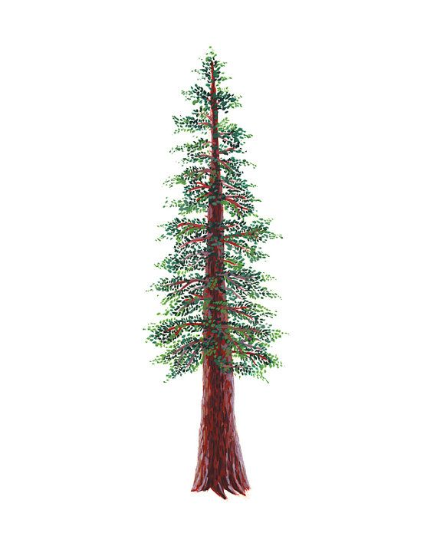
NORTH BAY LEAGUE REDWOOD DIVISION
Baseball Schedule 2023 – 2024
REVISED 6/1/23 TO INCLUDE ELSIE ALLEN HIGH SCHOOL AS A JV TEAM ONLY FOR 2024 SEASON.
Preseason coaches’ meeting: | TBA
All league selection meeting: | TBD
First day of practice | Monday, February 5
Number of contests: | 24 contests. A maximum of two scrimmages are permissible prior to the first contest (league or non league) of the season.
Game start time: | 3:30/4:00 PM

Round 1 | Round 2 | Round 3
Friday, March 8  Healdsburg at Montgomery  Santa Rosa at Piner  Elsie Allen at St. Vincent | Tuesday, April 2  Montgomery at Healdsburg  Piner at Santa Rosa  St. Vincent at Elsie Allen | Thursday, April 18  Santa Rosa at St. Vincent  Piner at Montgomery  Elsie Allen at Healdsburg
Wednesday, March 13  Montgomery at Santa Rosa  St. Vincent at Healdsburg  Piner at Elsie Allen | Thursday, April 4  Healdsburg at Montgomery  Santa Rosa at Piner  Elsie Allen at St. Vincent | Wednesday, April 24  Piner at St. Vincent  Santa Rosa at Healdsburg  Elsie Allen at Montgomery
Friday, March 15  Santa Rosa at St. Vincent  Piner at Montgomery  Elsie Allen at Healdsburg | Tuesday, April 9  Santa Rosa at Montgomery  Healdsburg at St. Vincent  Elsie Allen at Piner | Friday, April 26  St. Vincent at Piner  Healdsburg at Santa Rosa  Montgomery at Elsie Allen
Wednesday, March 27  St. Vincent at Piner  Santa Rosa at Healdsburg  Elsie Allen at Montgomery | Thursday, April 11  Montgomery at Santa Rosa  St. Vincent at Healdsburg  Piner at Elsie Allen | Wednesday, May 1  Healdsburg at Piner  St. Vincent at Montgomery  Santa Rosa at Elsie Allen
Friday, March 29  Piner at Healdsburg  Montgomery at St. Vincent  Elsie Allen at Santa Rosa | Tuesday, April 16  St. Vincent at Santa Rosa  Montgomery at Piner  Healdsburg at Elsie Allen | Friday, May 3  Piner at Healdsburg  Montgomery at St. Vincent  Elsie Allen at Santa Rosa
NBL CHAMPIONSHIPS
Wednesday, May 8: 1 at 4 and 2 at 3, site of highest seed
Friday, May 10: Rec Park 3:30pm Oak/6:30pm Redwood (alternates each year)
NCS CHAMPIONSHIP SERIES INFORMATION
Deadline for leagues to determine qualifiers: Friday, May 10
Final date for competition other than NCS Championships: Friday, May 10
NCS postseason applications due (automatic & at-larger): Friday, May 10, no later than 10 PM
At-large and seeding meeting: Saturday, May 11
Division 1, 3, 5 first round games: May 14
Division 2, 3, 6 first round games: May 15
Division 1, 3, 5 quarterfinal games: May 17
Division 2, 4 quarterfinal games, Division 6 semifinal games: May 18
Division 1, 3, 5 semifinal games: May 21
Division 2, 4 semifinal games: May 22
Division 1-6 NCS Championships: May 24 and 25
Nor-Cal Championships: May 28, May 30 and June 1
NCS Baseball Liaison: Sonjha Phillips, sphillips@cifncs.org

