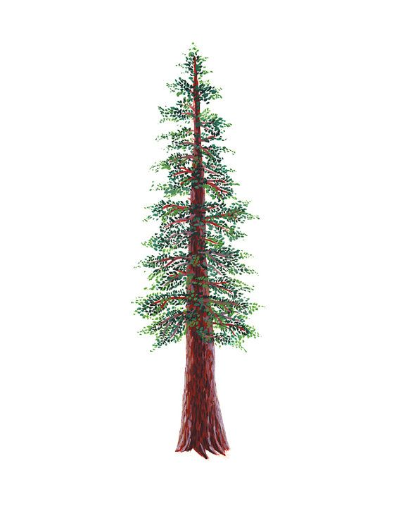
NORTH BAY LEAGUE
Boys’ Volleyball Schedule 2023 – 2024

Preseason coaches’ meeting: | TBA
First day of practice | Monday, February 5, 2024
Number of contests: | 24 matches and two scrimmages
Post-season/all-league selection meeting: | TBD
Tournaments | Each day of a tournament counts as 2 matches unless only one match is played
Match start time: | 5:00 PM

TUESDAY, MARCH 5 |  |  | THURSDAY, APRIL 4
 | American Canyon at Windsor |  |  | Windsor at American Canyon
 | Cardinal Newman at Sonoma |  |  | Sonoma at Cardinal Newman
 | Rancho Cotate at Analy |  |  | Analy at Rancho Cotate
 | Ukiah bye |  |  | Ukiah bye
THURSDAY, MARCH 7 |  |  | TUESDAY, APRIL 9
 | Analy at Ukiah |  |  | Ukiah at Analy
 | Sonoma at Rancho Cotate |  |  | Rancho Cotate at Sonoma
 | Windsor at Cardinal Newman |  |  | Cardinal Newman at Windsor
 | American Canyon bye |  |  | American Canyon bye
TUESDAY, MARCH 12 |  |  | THURSDAY, APRIL 11
 | Ukiah at Rancho Cotate |  |  | Rancho Cotate at Ukiah
 | Cardinal Newman at Analy |  |  | Analy at Cardinal Newman
 | Sonoma at American Canyon |  |  | American Canyon at Sonoma
 | Windsor bye |  |  | Windsor bye
THURSDAY, MARCH 14 |  |  | TUESDAY, APRIL 16
 | American Canyon at Ukiah |  |  | Ukiah at American Canyon
 | Rancho Cotate at Cardinal Newman |  |  | Cardinal Newman at Rancho Cotate
 | Windsor at Sonoma |  |  | Sonoma at Windsor
 | Analy bye |  |  | Analy bye
TUESDAY, MARCH 26 |  |  | THURSDAY, APRIL 18
 | Ukiah at Windsor |  |  | Windsor at Ukiah
 | Cardinal Newman at American Canyon |  |  | American Canyon at Cardinal Newman
 | Analy at Sonoma |  |  | Sonoma at Analy
 | Rancho Cotate bye |  |  | Rancho Cotate bye
THURSDAY, MARCH 28 |  |  | TUESDAY, APRIL 23
 | Cardinal Newman at Ukiah |  |  | Ukiah at Cardinal Newman
 | American Canyon at Rancho Cotate |  |  | Rancho Cotate at American Canyon
 | Windsor at Analy |  |  | Analy at Windsor
 | Sonoma bye |  |  | Sonoma bye
TUESDAY, APRIL 2 |  |  | THURSDAY, APRIL 25
 | Ukiah at Sonoma |  |  | Sonoma at Ukiah
 | Analy at American Canyon |  |  | American Canyon at Analy
 | Rancho Cotate at Windsor |  |  | Windsor at Rancho Cotate
 | Cardinal Newman bye |  |  | Cardinal Newman bye
NCS/Les Schwab Tires Championships
Final date for leagues to determine qualifiers: April 27
Final date for competition other than NCS or CIF Championships: April 27
NCS postseason applications due (automatic & at-large): April 27, 10 PM
NCS At Large meeting: April 28 (Coaches do not attend)
NCS Championships, April 30, May 2, 7, 9
CIF Nor-Cal Championships: May 14, 16, 18

