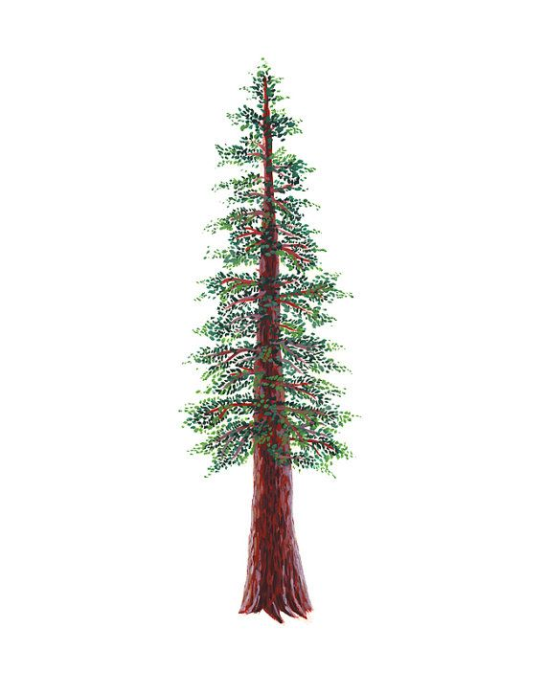
NORTH BAY LEAGUE REDWOOD DIVISION
Softball Schedule, 2023 – 2024
Revised 6/6/23

Preseason coaches’ meeting: | January 31st, 5:30pm at CN
First day of practice | February 5
Number of contests: | 24 games. A maximum of two scrimmages are permissible prior to the first contest (league or non-league) of the season.
Spring Break: | March 18 - 22
All-league selection mtg.: | May 6th, TBA
Game start time: | 4:00 PM/4:30 PM

TUESDAY, APRIL 2 | THURSDAY, APRIL 18
Ukiah at St. Vincent | St. Vincent at Ukiah
Piner at Santa Rosa | Santa Rosa at Piner
Elsie Allen at Healdsburg | Healdsburg at Elsie Allen
THURSDAY, APRIL 4 | TUESDAY, APRIL 23
St. Vincent at Piner | Piner at St. Vincent
Santa Rosa at Elsie Allen | Elsie Allen at Santa Rosa
Healdsburg at Ukiah | Ukiah at Healdsburg
TUESDAY, APRIL 9 | THURSDAY, APRIL 25
Piner at Ukiah | Ukiah at Piner
Elsie Allen at St. Vincent | St. Vincent at Elsie Allen
Santa Rosa at Healdsburg | Healdsburg at Santa Rosa
THURSDAY, APRIL 11 | TUESDAY, APRIL 30
St. Vincent at Healdsburg | Ukiah at Santa Rosa
Santa Rosa at Ukiah | Elsie Allen at Piner
Piner at Elsie Allen | Healdsburg at St. Vincent
TUESDAY, APRIL 16 | THURSDAY, MAY 2
Ukiah at Elsie Allen | Elsie Allen at Ukiah
Healdsburg at Piner | Piner at Healdsburg
St. Vincent at Santa Rosa | Santa Rosa at St. Vincent

NBL CHAMPIONSHIPS
Tuesday, May 9, 4 at 1 and 3 at 2 (site of highest seed)
Thursday, May 11: Winners at site of highest seed

NCS CHAMPIONSHIP SERIES INFORMATION
Deadline for leagues to determine qualifiers: Friday, May 10
Final date for competition other than NCS Championships: Friday, May 10
NCS postseason applications due (automatic & at-larger): Friday, May 10, no later than 10 PM
At-large and seeding meeting: Saturday, May 11
Division 1 – 6, first round games: May 14 - 15
Division 1 – 5, quarterfinal games/Division 6 semifinal games: May 17 - 18
Division 1 – 5, semifinal games: May 21 - 22
Division 1-6 NCS Championships: May 24 and 25
Nor-Cal Championships: May 28, May 30 and June 1

NCS Softball liaison: Bri Niemi, bniemi@cifncs.org

