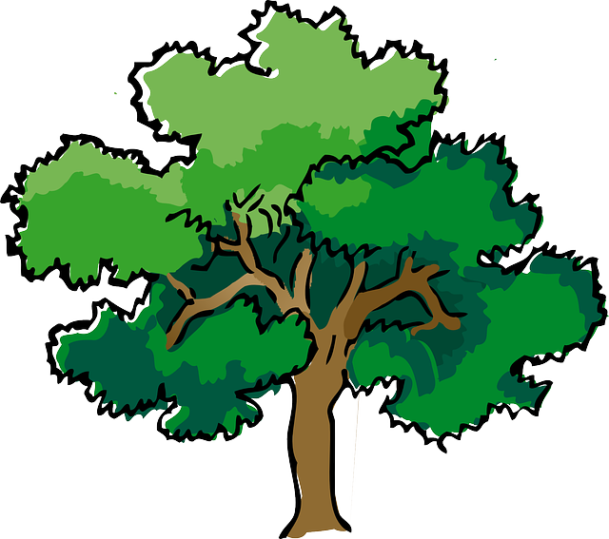
NORTH BAY LEAGUE OAK DIVISION
Baseball Schedule 2023 – 2024

Preseason coaches’ meeting: |  | Wednesday, January 31, 7:00 PM Cardinal Newman ACC
All league selection meeting: |  | Monday, May 6 TBD
First day of practice |  | Monday, February 5
Number of contests: |  | 24 contests. A maximum of two scrimmages are permissible prior to the first contest (league or non league) of the season.
Game start time: |  | 4:00 PM
WEDNESDAY, APRIL 3 |  |  |  | FRIDAY, APRIL 19
 | Windsor at Rancho Cotate |  |  |  | Analy at Rancho Cotate
 | Cardinal Newman at Analy |  |  |  | Ukiah at Windsor
 | Maria Carrillo at Ukiah |  |  |  | Cardinal Newman at Maria carrillo
FRIDAY, APRIL 5 |  |  |  | TUESDAY, APRIL 23
 | Rancho Cotate at Windsor |  |  |  | Maria Carrillo at Windsor
 | Analy at Cardinal Newman |  |  |  | Cardinal Newman at Rancho Cotate
 | Ukiah at Maria Carrillo |  |  |  | Analy at Ukiah
WEDNESDAY, APRIL 10 |  |  |  | THURSADY, APRIL 25
 | Analy at Windsor |  |  |  | Windsor at Maria Carrillo
 | Ukiah at Cardinal Newman |  |  |  | Rancho Cotate at Cardinal Newman
 | Rancho Cotate at Maria Carrillo |  |  |  | Ukiah at Analy
FRIDAY, APRIL 12 |  |  |  | TUESDAY, APRIL 30
 | Windsor at Analy |  |  |  | Ukiah at Rancho Cotate
 | Cardinal Newman at Ukiah |  |  |  | Analy at Maria Carrillo
 | Maria Carrillo at Rancho Cotate |  |  |  | Windsor at Cardinal Newman
WEDNESDAY, APRIL 17 |  |  |  | THURSDAY, MAY 2
 | Rancho Cotate at Analy |  |  |  | Rancho Cotate at Ukiah
 | Windsor at Ukiah |  |  |  | Maria Carrillo at Analy
 | Maria Carrillo at Cardinal Newman |  |  |  | Cardinal Newman at Windsor

NBL CHAMPIONSHIPS
Wednesday, May 8: 1 at 4 and 2 at 3, site of highest seed
Friday, May 10: Rec Park 3:30pm Oak/6:30pm Redwood (alternates each year)

NCS CHAMPIONSHP SERIES INFORMATION
Deadline for leagues to determine qualifiers: Friday, May 10
Final date for competition other than NCS Championships: Friday, May 10
NCS postseason applications due (automatic & at-larger): Friday, May 10, no later than 10 PM
At-large and seeding meeting: Saturday, May 11
Division 1, 3, 5 first round games: May 14
Division 2, 4, 6 first round games: May 15
Division 1, 3, 5 quarterfinal games: May 17
Division 2, 4 quarterfinal games, Division 6 semifinal games: May 18
Division 1, 3, 5 semifinal games: May 21
Division 2, 4 semifinal games: May 22
Division 1-6 NCS Championships: May 24 and 25
Nor-Cal Championships: May 28, May 30 and June 1

