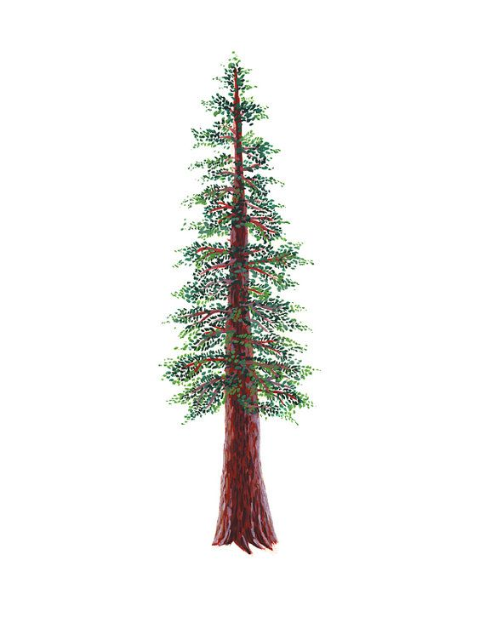
NORTH BAY LEAGUE BOYS’ WRESTLING
ALL LEAGUE TEAM, 2022 – 2023

WRESTLER OF THE YEAR
170 | Logan Bruce |  | 10 | Maria Carrillo
FIRST TEAM
Wt. | First Name | Last Name | Grade | School
106 | Antonio | Garaventa | 9 | Windsor
113 | Garret | Nunemaker | 12 | Ukiah
120 | Chase | Claassen | 10 | Windsor
126 | Austin | Fredricksen | 12 | Windsor
132 | Vincent | Tyrell | 12 | Ukiah
138 | Kenji | Jiminez | 12 | Ukiah
145 | Jayce | Toupin | 12 | Windsor
152 | Jared | William | 11 | Ukiah
160 | Kaeden | Timmons | 12 | Windsor
170 | Logan | Bruce | 10 | Maria Carrillo
182 | Welsey | Wolff | 11 | Montgomery
195 | Michael | Turk | 11 | Montgomery
220 | Dante | Brown | 12 | Ukiah
285 | Lestat | Cisneros | 12 | Ukiah
SECOND TEAM
 | First Name | Last Name | Grade | School
106 | William | Harvey | 9 | Maria Carrillo
113 | Bradley | Harbaugh | 12 | Maria Carrillo
120 | Nico | Gonzalez | 11 | Ukiah
126 | Kymani | Capri | 12 | Ukiah
132 | Christian | Matamoros | 10 | Windsor
138 | Santino | Campos | 11 | Windsor
145 | Dan | Rensen | 10 | Ukiah
152 | Jonathan | Chavez | 12 | Piner
160 | Syrus | Olvera | 11 | Rancho Cotate
170 | Tyson | Timmons | 10 | Windsor
182 | Cesar | Diaz | 11 | Windsor
195 | Juan | Nunez | 10 | Piner
220 | Elijah | Colter | 12 | Maria Carrillo
285 | Devon | Bertoli | 9 | Cardinal Newman
HONORABLE MENTION
Wt. | First Name | Last Name | Grade | School
106 | Raven | Costa | 10 | Ukiah
113 | Eric | McDonell | 9 | Cardinal Newman
120 | Eric | Chambers | 11 | Elsie Allen
126 | Emmanuel | Gaspar | 12 | Maria Carrillo
132 | Adam | Harbaugh | 12 | Maria Carrillo
138 | Miguel | Ibarra | 11 | Rancho Cotate
145 | Arno | Makaryan | 11 | Montgomery
152 | Dylan | Olsen | 9 | Maria Carrillo
160 | Eduardo | Martinez | 12 | Ukiah
170 | Johan | Bertoli | 9 | Cardinal Newman
182 | Henry | Meyer | 12 | Ukiah
195 | Marquez | Deneiliom | 12 | Elsie Allen
220 | Diego | Barbosa | 9 | Piner
285 | Ryan | George | 10 | Montgomery

