 | NORTH BAY LEAGUE  Joe Ellwood, Commissioner  jellwood@wscuhsd.org; (707)484-8410  Dean Haskins, Commissioner  dhaskins@srcs.k12.ca.us; (707) 484-0271 | 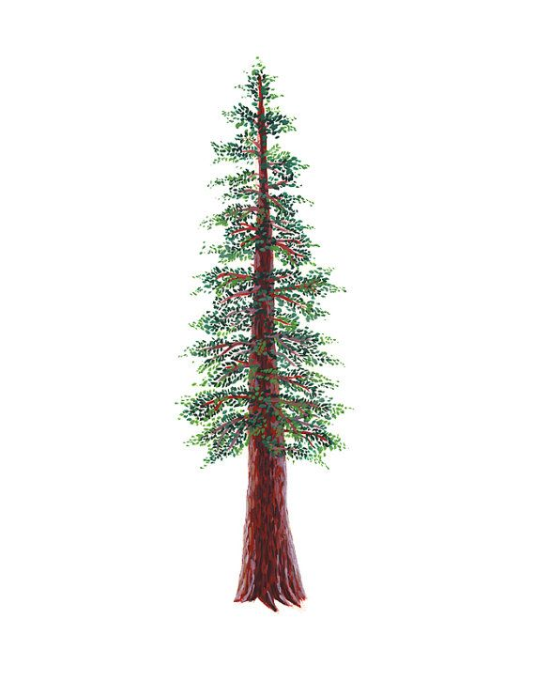

ATHLETIC DIRECTORS MEETING MINUTES, MONDAY, DECEMBER 12 ,2022
ATTENDANCE
Joe Ellwood | Analy | Kenny Knowlton | Santa Rosa
Monica Mertle | Cardinal Newman | Bryan Price | Santa Rosa
Ry Basham-Mintz | Elsie Allen | Heather Campbell | St. Vincent
Josh Cavanagh | Healdsburg | Stephen Summers | Ukiah
Jerry Deakins | Maria Carrillo | Jamie Williams | Windsor
Dean Haskins | Montgomery
Ryan Riddle | Piner | Joe Ellwood | Commissioner
Scotty McKeon | Rancho Cotate | Dean Haskins | Commissioner

I. | APPROVAL OF AGENDA
Motion to approve the agenda as presented.
Motion: Rancho Cotate
Second: Ukiah
Motion approved unanimously
II. | APPROVAL OF THE NBL CONSENT AGENDA
 | There was no consent agenda for this meeting.
III. | APPROVAL OF MINUTES FOR THE PREVIOUS MEETING 1st St. Vincent 2nd SRHS
Previously emailed and available online at www.northbayleague.org
Motion to approve the minutes of the previous meeting.
Motion: St. Vincent
Second: Santa Rosa
Motion approved unanimously
IV. | PUBLIC COMMENT
 | Pursuant to Education Code Section 54954.3 and Education Code section 33353, any member of the public wishing to speak on any matter within the subject matter jurisdiction of the NBL, CIF, and NCS will be heard at this time. The time for such comment is no more than two (2) minutes per person on an item and no more than twenty (20) minutes total on an item or as designated by the Chair.
V. | NORTH BAY LEAGUE AGENDA ITEMS
 | A. | Presentation by Lauren Mulhern and Benito Comma on Unified Sports
Discussion
Make this year an exhibition year so scoring does affect meet scoring and get the program started.
Lauren and Benito met with track coaches at the track and field preseason meeting.
 | B. | Principals’ Meeting
Monday, January 23, 2023 at 3 PM at Piner High School
Winter and Spring draws will be held at this meeting
 | C. | Rancho Cotate Pool Update
 |  | Rancho Cotate will not be able to host any home swim events this season. The Cougars will swim at their opponent’s swimming pool for all swim meets.
 | D. | Elsie Allen Football
 |  | Elsie Allen is pursuing supplemental placement in the Coastal Mountain Conference and the NCL II for 8-person football.
 | E. | Badminton
 |  | The following schools will have badminton this year: Analy, Elsie Allen, Healdsburg, Rancho Cotate, Santa Rosa. Maria Carrillo, Montgomery, Piner, Roseland Collegiate Prep, Roseland University Prep, Santa Rosa and Windsor.
 | F. | Football Realignment Bylaws
Discussion of the MCAL, VVAL and NBL football bylaws.
Napa High School is appealing their placement in group three and would like to move to group two.
 | G. | SAC Meeting Update
 |  | a. | Maximum number of contests failed—8 yes and 25 no.  This item was not supported by the NCS Executive Committee, but will be listed as an action item at the January 27 NCS Board of Managers Meeting.
 |  | b. | Proposal to restructure NCS Playoffs in several sports.  Discussion of part II of the proposal from the WACC: Placing schools in NCS divisions. The proposal requests that a seeding committee place schools selected for the playoffs on one list based on the committee’s perception of competitive equity--strongest to weakest. Basketball, for example, would have one list of 104 schools ranked by competitive equity.  Discussion on what is the “nuts and bolts”  - Minimum Qualifying Record: Eliminate the .500 minimum overall record and .500 league record. There was discussion on keeping the .500 record within the division but if new divisions this might not be possible.  - Would a league champion still host a first-round game? NBL has members that want pure seeding and the highest seed is the host and some members think the league champion should be the 1st round host (travel distance for preseason games if an issue).  - Seeding selection: keep coaches ranking as coaches like a voice. A couple of NBL ADs discussed eliminating coaches' rankings.  - How would automatic qualifiers be determined? Need more discussion on this item.  - League interest in providing an opportunity for an at-large group to apply that didn’t meet the .500 qualifying record.? Yes, fill in the bracket if possible.  - League interest in concluding the regular season of sport on Friday rather than Saturday? NBL schools prefer Saturday as the concluding day for the regular season.  - Football Division Comparison with NCS FB playoff using MaxPreps and .500 record with NCS Model (Comp equity/seeding within static division.  An NBL Meeting was scheduled for January 17. 2023 to discuss this item and develop a plan to present to principals on 1/23/23. The meeting will be held at the Lewis Learning Center and will begin at 10 AM.
 |  | c. | Thirty days prior to the first official day of practice, teams may institute an acclimation period, where student-athletes will have the use of a helmet throughout much of the summer. No live-contact drills will be allowed. All allowable drills per the NCS in a normal summer period will be permissible; this would simply give teams the option of adding a helmet to normal allowable summer activity to better prepare for the season. Passed: 20 yes, 13 no.
 | H. | NCS Sportsmanship
Continue to educate your school communities.
- Positive sportsmanship is not only a point of emphasis this year for the NCS, but also nationwide for the CIF and NFHS. Earlier this year, the CIF Sportsmanship Toolkit was shared with NCS member schools. As part of the December Sportsmanship call out, the NFHS Bench Bad Behavior Toolkit will not be shared. The National Federation of State High School Associations (NFHS) created this toolkit for high school administrators to use. The toolkit includes resources that you can use to proactively address bad behavior at your high school athletic events. Additionally, please nominate schools/teams/individuals who you come across who have exhibited great sportsmanship: Outstanding Sportsmanship Nomination Form.
- There have been FIVE assaults on officials to date within the North Coast Section. Please make sure you have protocols in place for management of officials pre- and post-event. And that your student-athletes and coaches are aware that an assault on an official will result in ineligibility for the offending student-athlete for the remainder of his/her high school career and that coaches will have penalties set by school districts and the NCS.
- Any interest in selecting two dates for Boys’ and Girls’ basketball and calling it Officials’ Appreciation Night? What would that look like? Dean will be solicitation ideas from the Assistant Principal at Fortuna High School, who has already developed an officials’ appreciation program.
 | I. | Eligibility Meeting Information  Joe presented a summary of the latest NCS Eligibility Committee Meeting.  - Undue Influence Grid. Leagues are expected to review several items on this grad so that the Eligibility Committee will have that date to review at their March 1, 2023 meeting.  - Review of the Hardship Bylaws  - Reminders regarding CIF Home

NEXT AD MEETING: TUESDAY, JANUARY 17, 2023
10 AM, Lewis Learning Center

