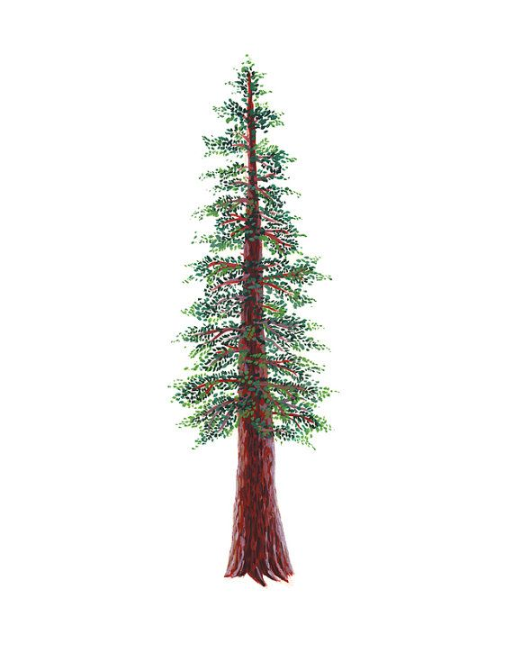
NORTH BAY LEAGUE REDWOOD DIVISION
Girls’ Golf Schedule, 2022 – 2023
(Year 1 of a two-year rotation)

Preseason Meeting: | Monday, August 1, 4 PM, Montgomery High School
First day of practice: | Monday, Aug 8, 2022
Number of contests: | 22 matches; no scrimmages; double-round robin, 9 hole matches
Tournaments: | Each match counts as one contest
Match start time: | TBD

Tuesday, September 13  Maria Carrillo at Ukiah  Healdsburg at West county | Thursday, September 29  9 Hole Mini Tournament Site TBA  Ukiah, Maria Carrillo, West County, Healdsburg
Thursday, September 15  Healdsburg at Maria Carrillo  West county at Ukiah | Tuesday, October 4  Maria Carrillo at Healdsburg  Ukiah at West County
Tuesday, September 20  Ukiah at Healdsburg  Maria Carrillo at West County | Thursday, October 6  9 Hole Mini Tournament Site TBA  Ukiah, Maria Carrillo, West County, Healdsburg
Thursday, September 22  9 Hole Mini Tournament Site TBA  Ukiah, Maria Carrillo, West County, Healdsburg | Tuesday October 11  Healdsburg at Ukiah  West County at Maria Carrillo
Tuesday, September 27  Ukiah at Maria Carrillo  West County at Healdsburg | Thursday, October 13  9 Hole Mini Tournament Site TBA  Ukiah, Maria Carrillo, West County, Healdsburg

NCS Singles Qualifying Tournament: Monday, October 17 at Rooster Run; host TBD

NCS/Les Schwab Tires Championships
Deadline for leagues to determine qualifiers: Tuesday, October 18
Automatic league qualifier entries and at-large applications due no later than 8 PM on October 18; forms available at www.cifncs.org
At-large meeting: Wednesday, October 19 (NCS Committee, coaches do not attend)
Division 2 Championship/Individual Qualifier (pending course availability: Monday, October 24
Division 1 Championship (pending course availability): Monday, October 31st
Northern California Golf Championships: Monday, November 7; course to be determined
CIF State Championships: Wednesday, November 16; course to be determined

CIF Bylaw 504m (SUNDAY RESTRICTIONS) In order to provide at least one day of respite from involvement in interscholastic athletics each week, no interscholastic games or practices of any kind are to be held on Sunday.

