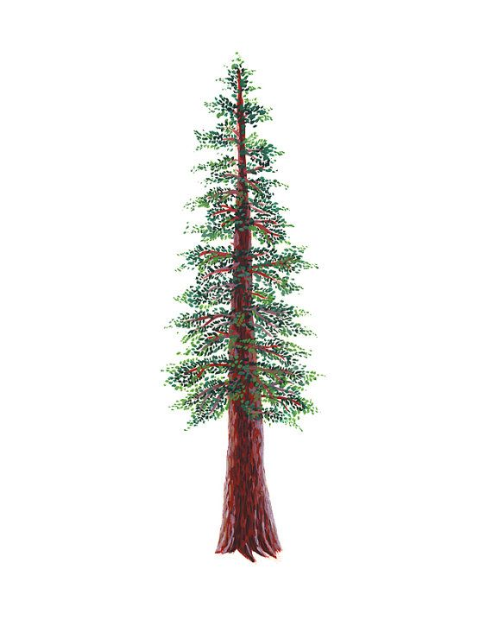
NORTH BAY LEAGUE
Cross Country Schedule, 2023 – 2024

Pre-season meeting: | TBA
First day of practice: | Monday, August 7
Number of contests: | 14 meets  A maximum of two (2) scrimmages are permissible prior to the first interscholastic contest (league or non-league) of the season.
Meet time:

OAK |  | REDWOOD
WEDNESDAY, SEPTEMBER 27 |  | WEDNESDAY, SEPTEMBER 27
Windsor at Montgomery |  | Rancho Cotate at Analy
Piner at Maria Carrillo |  | Ukiah at Cardinal Newman
Santa Rosa bye |  | Healdsburg at St Vincent/Elsie Allen
WEDNESDAY, OCTOBER 4 |  | WEDNESDAY, OCTOBER 4
Windsor at Maria Carrillo |  | Ukiah at Rancho Cotate
Santa Rosa at Piner |  | Cardinal Newman at Healdsburg
Montgomery bye |  | Analy at St. Vincent/Elsie Allen
WEDNESDAY, OCTOBER 11 |  | WEDNESDAY, OCTOBER 11
Maria Carrillo at Montgomery |  | Analy at Ukiah
Santa Rosa at Windsor |  | Rancho Cotate at Healdsburg
Piner bye |  | Elsie Allen/St. Vincent at Cardinal Newman
WEDNESDAY, OCTOBER 18 |  | WEDNESDAY, OCTOBER 18
Windsor bye |  | Elsie Allen/St. Vincent at Rancho Cotate
Montgomery at Piner |  | Cardinal Newman at Analy
Maria Carrillo at Santa Rosa |  | Ukiah at Healdsburg
WEDNESDAY, OCTOBER 25 |  | WEDNESDAY, OCTOBER 25
Montgomery at Santa Rosa |  | Healdsburg at Analy
Maria Carrillo bye |  | Elsie Allen/St. Vincent at Ukiah
Piner at Windsor |  | Cardinal Newman at Rancho Cotate
WEEK OF NOVEMBER 6 |  | WEEK OF NOVEMBER 6
NBL Championship Meet |  | NBL Championship Meet
Site and host(s) TBD |  | Site and host(s) TBD

NCS/Les Schwab Tires Championships
Final date for competition other than NCS Championships: November 12
NCS entries due: November 13 (11:59 PM)
Meet of Champions: November 19
CIF Cross Country Championships: November 26, Woodward Park, Fresno

Note:
If St. Vincent fields a cross country team in the 2022 – 2023 season, they will be grouped with Elsie Allen in all meets. Elsie Allen and St. Vincent will rotate hosting home events or work together to host at either Elsie Allen or St. Vincent.

