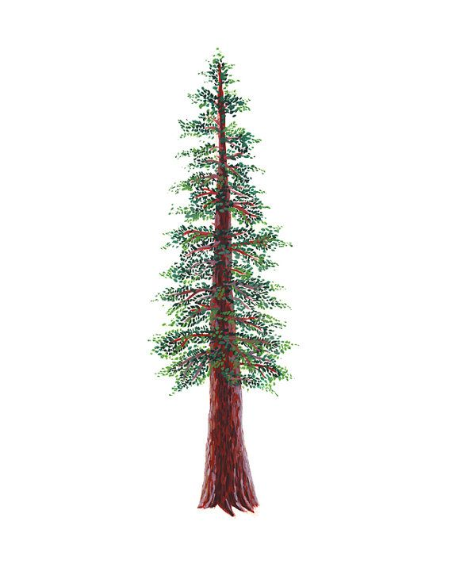
NORTH BAY LEAGUE
Cross Country Schedule, 2022 – 2023

Pre-season meeting: | Monday, August 2, 5:00 PM, site MHS Room 80
First day of practice: | Monday, August 8
Number of contests: | 14 meets  A maximum of two (2) scrimmages are permissible prior to the first interscholastic contest (league or non-league) of the season.
Meet time:

OAK |  | REDWOOD
WEDNESDAY, SEPTEMBER 28 |  | WEDNESDAY, SEPTEMBER 28
Montgomery at Windsor |  | West County at Rancho Cotate
Maria Carrillo at Piner |  | Cardinal Newman at Ukiah
Santa Rosa bye |  | Elsie Allen at Healdsburg
WEDNESDAY, OCTOBER 5 |  | WEDNESDAY, OCTOBER 5
Maria Carrillo at Windsor |  | Rancho Cotate at Ukiah
Piner at Santa Rosa |  | Healdsburg at Cardinal Newman
Montgomery |  | Elsie Allen at West County
WEDNESDAY, OCTOBER 12 |  | WEDNESDAY, OCTOBER 12
Montgomery at Maria Carrillo |  | Ukiah at West County
Windsor at Santa Rosa |  | Healdsburg at Rancho Cotate
Piner bye |  | Cardinal Newman at Elsie Allen
WEDNESDAY, OCTOBER 19 |  | WEDNESDAY, OCTOBER 19
Windsor bye |  | Rancho Cotate at Elsie Allen
Piner at Montgomery |  | West County at Cardinal Newman
Santa Rosa at Maria Carrillo |  | Healdsburg at Ukiah
WEDNESDAY, OCTOBER 26 |  | WEDNESDAY, OCTOBER 26
Santa Rosa at Montgomery |  | West County at Healdsburg
Maria Carrillo bye |  | Ukiah at Elsie Allen
Windsor at Piner |  | Rancho Cotate at Cardinal Newman
WEEK OF NOVEMBER 4th & 5th |  | WEEK OF NOVEMBER 4th &5th
NBL Championship Meet |  | NBL Championship Meet
Site and host(s) TBD |  | Site and host(s) TBD

NCS/Les Schwab Tires Championships
Final date for competition other than NCS Championships: November 12
NCS entries due: November 13 (11:59 PM)
Meet of Champions: November 19
CIF Cross Country Championships: November 26, Woodward Park, Fresno

Note:
If St. Vincent fields a cross country team in the 2022 – 2023 season, they will be grouped with Elsie Allen in all meets. Elsie Allen and St. Vincent will rotate hosting home events or work together to host at either Elsie Allen or St. Vincent.

