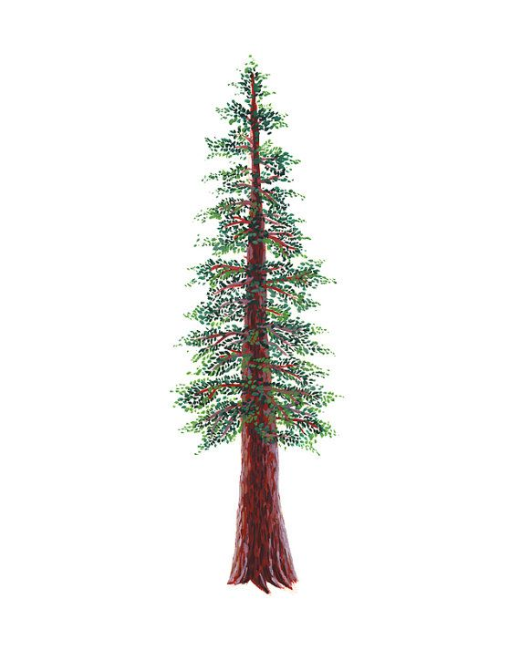

ALL-LEAGUE REDWOOD FOOTBALL NOMINATIONS, 2021 – 2022

CO-MOST VALUABLE PLAYER

# | FIRST NAME | LAST NAME | POSITION | GRADE | SCHOOL
11 | MASON | HALLIN | WR/DB | 12 | MONTGOMERY
2 | DANTE | ANTONINI | WR/LB | 12 | ST. VINCENT

OFFENSIVE PLAYER OF THE YEAR

# | FIRST NAME | LAST NAME | POSITION | GRADE | SCHOOL
25 | KAI | HALL | RB | 12 | ST. VINCENT

DEFENSIVE PLAYER OF THE YEAR

# | FIRST NAME | LAST NAME | POSITION | GRADE | SCHOOL
27 | SAM | VALENTI | DT | 10 | MONTGOMERY

BACK OF THE YEAR

# | FIRST NAME | LAST NAME | POSITION | GRADE | SCHOOL
5 | CARLITOS | PARDO | RB | 12 | SANTA ROSA

DEFENSIVE BACK OF THE YEAR

# | FIRST NAME | LAST NAME | POSITION | GRADE | SCHOOL
11 | NOLAN | FROST | DB | 11 | SANTA ROSA

LINEMAN OF THE YEAR

# | FIRST NAME | LAST NAME | POSITION | GRADE | SCHOOL
52 | DOMINIC | MINTON | LT/DT | 12 | ST. VINCENT

SPECIALIST OF THE YEAR

# | FIRST NAME | LAST NAME | POSITION | GRADE | SCHOOL
88 | DANIEL | ESCUTIA | K | 12 | SANTA ROSA

FIRST TEAM ALL LEAGUE NOMINATIONS

QUARTERBACK

# | FIRST NAME | LAST NAME | POSITION | GRADE | SCHOOL
4 | LUCAS | FOYE | QB | 11 | MONTGOMERY

RUNNING BACKS

# | FIRST NAME | LAST NAME | POSITION | GRADE | SCHOOL
9 | JAXSON | HOWLEY | RB | 12 | MONTGOMERY
5 | JOSE | NUNEZ | RB | 12 | HEALDSBURG

WIDE RECEIVERS

# | FIRST NAME | LAST NAME | POSITION | GRADE | SCHOOL
2 | KEEGAN | PETERSON | WR | 11 | MONTGOMERY
11 | NOLAN | FROST | WR | 11 | SANTA ROSA
9 | MATTHEW | TELDESCHI | WR | 12 | HEALDSBURG

TIGHTEND/H-BACK

# | FIRST NAME | LAST NAME | POSITION | GRADE | SCHOOL
22 | JAKE | DECARLI | TE | 12 | ST. VINCENT
3 | ANMOL | SINGH | TE | 12 | SANTA ROSA

LINEMEN (4)

# | FIRST NAME | LAST NAME | POSITION | GRADE | SCHOOL
75 | CAMERON | VAUGHN | OL | 11 | ST. VINCENT
70 | ASHER | BLAIN | OL | 11 | MONTGOMERY
52 | FRANKIE | RIVIERA | OL | 12 | MONTGOMERY
54 | GARRETT | BONNIN | OL | 12 | SANTA ROSA
55 | MANUEL | GARCIA | OL | 12 | SANTA ROSA

DEFENSE

DEFENSIVE BACKS

# | FIRST NAME | LAST NAME | POSITION | GRADE | SCHOOL
7 | JARET | BOSARGE | SS/DB | 11 | ST. VINCENT
2 | KEEGAN | PETERSON | DB | 11 | MONTGOMERY
2 | JULIAN | ASTOBIZA | DB | 12 | SANTA ROSA
9 | MATTHEW | TELDESCHI | DB | 12 | HEALDSBURG

DEFENSIVE LINEMEN (4)

# | FIRST NAME | LAST NAME | POSITION | GRADE | SCHOOL
17 | KILLIAN | COLLINS | DE | 12 | ST. VINCENT
25 | GEORGE | MEISLER | DL | 12 | MONTGOMERY
88 | ELIJAH | SAXTON | DL | 12 | MONTGOMERY
50 | BORIS | MARTINEZ | DL | 12 | SANTA ROSA

INSIDE LINEBACKER

# | FIRST NAME | LAST NAME | POSITION | GRADE | SCHOOL
3 | NATHAN | ROOKS | LB | 11 | ST. VINCENT
22 | JAYDON | SHAW | LB | 12 | MONTGOMERY

OUTSIDE LINEBACKERS

# | FIRST NAME | LAST NAME | POSITION | GRADE | SCHOOL
23 | DOMINIC | OLIVO | OLB | 12 | MONTGOMERY
22 | ADAN | LEMUS | OLB | 10 | SANTA ROSA
22 | JAKE | DECARLI | OLB | 12 | ST. VINCENT

SECOND TEAM ALL LEAGUE NOMINATIONS

QUARTERBACK

# | FIRST NAME | LAST NAME | POSITION | GRADE | SCHOOL
2 | JULIAN | ASTOBIZA | QB | 12 | SANTA ROSA

RUNNING BACKS

# | FIRST NAME | LAST NAME | POSITION | GRADE | SCHOOL
32 | ADRIAN | MADRIGAL | RB | 12 | SANTA ROSA
8 | CAMERON | PIPPI | RB | 11 | HEALDSBURG

WIDE RECEIVERS

# | FIRST NAME | LAST NAME | POSITION | GRADE | SCHOOL
44 | KILLIAN | COLLINS | WR | 12 | ST. VINCENT
84 | ELI | WINKELMAN | WR | 12 | SANTA ROSA
3 | JUSTIN | MERRIKEN | WR | 12 | MONTGOMERY

LINEMEN

# | FIRST NAME | LAST NAME | POSITION | GRADE | SCHOOL
58 | ROBERT | ROOKS | OL | 9 | ST. VINCENT
50 | JUSTIN | KOPPY | OL | 12 | MONTGOMERY
50 | BORIS | MARTINEZ | OL | 12 | SANTA ROSA
71 | ALEXIS | SOLANO | OL | 12 | SANTA ROSA
57 | LOGAN | CARDONA | OL | 10 | HEALDSBURG

DEFENSIVE BACKS

# | FIRST NAME | LAST NAME | POSITION | GRADE | SCHOOL
9 | MALCOM | ROOKS | DB | 10 | ST. VINCENT
32 | LIAM | OHARE | DB | 12 | ST. VINCENT
84 | ELI | WINKELMAN | DB | 12 | SANTA ROSA
17 | ANGEL | VILLANUEVA | DB | 12 | SANTA ROSA

DEFENSIVE LINEMAN

# | FIRST NAME | LAST NAME | POSITION | GRADE | SCHOOL
51 | RILEY | GILFILLIAN | DL | 12 | ST. VINCENT
52 | FRANKIE | RIVERA | DL | 12 | MONTGOMERY
9 | JAXSON | HOWLEY | DL | 12 | MONTGOMERY
32 | ADRIAN | MADRIGAL | DL | 12 | SANTA ROSA
55 | MANUEL | GARCIA | DL | 12 | SANTA ROSA

INSIDE LINEBACKERS

# | FIRST NAME | LAST NAME | POSITION | GRADE | SCHOOL
13 | COLTON | WHITESTINE | LB | 11 | MONTGOMERY
6 | LOUWEGIE | ARRIAGA | LB | 11 | SANTA ROSA
4 | MATT | ERICKSON | LB | 10 | PINER

OUTSIDE LINEBACKERS

# | FIRST NAME | LAST NAME | POSITION | GRADE | SCHOOL
10 | OWEN | FAUSTINO | OLB | 11 | MONTGOMERY
15 | MATTHEW | ROWLAND | OLB | 12 | HEALDSBURG
22 | NATHANIEL | ROWLAND | OLB | 9 | HEALDSBURG

