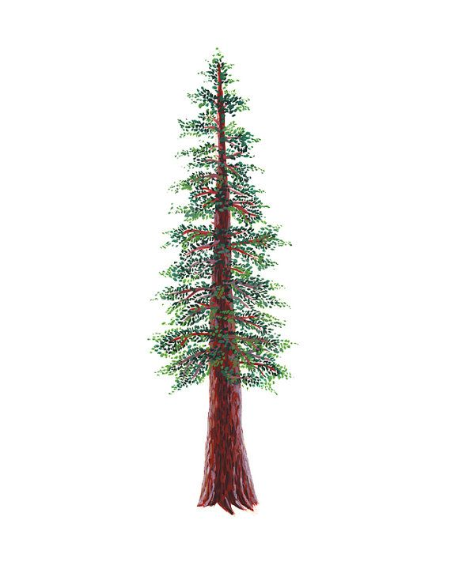
NORTH BAY LEAGUE
Girls’ Tennis Schedule, 2023 – 2024
(Year 2 of a two-year rotation)

Preseason Meeting: | TBA
First day of practice: | Monday, August 7
Number of contests: | 24 matches  A maximum of two scrimmages is permissible prior to the first interscholastic contest (league or non-league) of the season.
Tournaments: | Each match counts as one contest
Match start time: | 4:00 PM

THURSDAY, AUGUST 24  Piner at Rancho Cotate  Windsor at Cardinal Newman  Montgomery at Maria Carrillo  Santa Rosa at Healdsburg  Analy at Ukiah  TUESDAY, AUGUST 29  Rancho Cotate at Windsor  Cardinal Newman at Piner  Montgomery at Healdsburg  Ukiah at Maria Carrillo  Santa Rosa at Analy  THURSDAY, AUGUST 31  Rancho Cotate at Montgomery  Piner at Maria Carrillo  Ukiah at Windsor  Cardinal Newman at Santa Rosa  Healdsburg at Analy  TUESDAY, SEPTEMBER 5  Rancho Cotate at Cardinal Newman  Windsor at Piner  Montgomery at Santa Rosa  Healdsburg at Ukiah  Analy at Maria Carrillo  THURSDAY, SEPTEMBER 7  Piner at Ukiah  Santa Rosa at Rancho Cotate  Windsor at Healdsburg  Maria Carrillo at Cardinal Newman  Montgomery at Analy  TUESDAY, SEPTEMBER 12  Ukiah at Cardinal Newman  Montgomery at Windsor  Maria Carrillo at Santa Rosa  Rancho Cotate at Healdsburg  Analy at Piner  THURSDAY, SEPTEMBER 14  Maria Carrillo at Rancho Cotate  Santa rosa at Ukiah  Piner at Healdsburg  Montgomery at Cardinal Newman  Analy at Windsor  TUESDAY, SEPTEMBER 19  Rancho Cotate at Ukiah  Montgomery at Piner  Healdsburg at Maria Carrillo  Windsor at santa Rosa  Analy at Cardinal Newman  THURSDAY, SEPTEMBER 21  Santa Rosa at Piner  Cardinal Newman at Healdsburg  Maria Carrillo at Windsor  Ukiah at Montgomery  Rancho Cotate at Analy |  | TUESDAY, SEPTEMBER 26  Rancho Cotate at Piner  Cardinal Newman at Windsor  Maria Carrillo at Montgomery  Healdsburg at Santa Rosa  Ukiah at Analy  THURSDAY, SEPTEMBER 28  Windsor at Rancho Cotate  Piner at Cardinal Newman  Healdsburg at Montgomery  Maria Carrillo at Ukiah  Analy at Santa Rosa  TUESDAY, OCTOBER 3  Montgomery at Rancho Cotate  Maria Carrillo at Piner  Windsor at Ukiah  Santa Rosa at Cardinal Newman  Analy at Healdsburg  THURSDAY, OCTOBER 5  Cardinal Newman at Rancho Cotate  Piner at Windsor  Santa Rosa at Montgomery  Ukiah at Healdsburg  Maria Carrillo at Analy  TUESDAY, OCTOBER 10  Ukiah at Piner  Rancho Cotate at Santa Rosa  Healdsburg at Windsor  Cardinal Newman at Maria Carrillo  Analy at Montgomery  THURSDAY, OCTOBER 12  Cardinal Newman at Ukiah  Windsor at Montgomery  Santa Rosa at Maria Carrillo  Healdsburg at Rancho Cotate  Piner at Analy  THURSDAY, OCTOBER 17  Rancho Cotate at Maria Carrillo  Ukiah at Santa Rosa  Healdsburg at Piner  Cardinal Newman at Montgomery  Windsor at Analy  THURSDAY, OCTOBER 19  Ukiah at Rancho Cotate  Piner at Montgomery  Maria Carrillo at Healdsburg  Santa Rosa at Windsor  Cardinal Newman at Analy  TUESDAY, OCTOBER 24  Piner at Santa Rosa  Healdsburg at Cardinal Newman  Windsor at Maria Carrillo  Montgomery at Ukiah  Analy at Rancho Cotate
Singles Tournament: Thursday, October 26 and Friday, October 27
Doubles Tournament: Wednesday, November 1 and Thursday, November 2
NCS/Les Schwab Tires Championships
Deadline for leagues to determine qualifiers in team tennis: November 4 (Team Tennis only)
Final date for team competition other than NCS Championships: November 4 (Team Tennis only)
NCS Postseason team applications due (automatic & at-large): November 4, 9 PM
At-large and seeding meeting for team tennis: November 5
Team Tennis Championships, Divisions 1 & 2: November 7, 9, 11
CIF Nor-Cal Team Tennis Championships: November 14*, 17-18
Deadline for leagues to determine qualifiers for singles/doubles: November 8
Final date for singles/doubles competition other than NCS Championships: November 8
NCS Postseason singles/doubles applications (automatic & at-large) due: November 8, 9 PM
Singles At-large Mtg.: November 9
Singles/Doubles Championships: November 13 – 14

