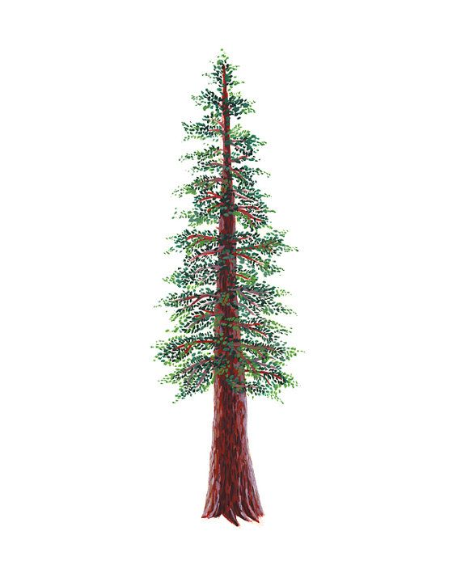
NORTH BAY LEAGUE
Girls’ Tennis Schedule, 2024 – 2025
(Year 1 of a two-year rotation)

Preseason Meeting: | TBA
First day of practice: | Monday, August 12
Number of contests: | 24 matches  A maximum of two scrimmages is permissible prior to the first interscholastic contest (league or non-league) of the season.
Tournaments: | Each match counts as one contest
Match start time: | 4:00 PM
Revised 3/13/24
TUESDAY, AUGUST 27  Healdsburg at Cardinal Newman  Rancho Cotate at Piner  Ukiah at Analy  Santa Rosa at Montgomery  Maria Carrillo at Windsor  THURSDAY, AUGUST 29  Piner at Healdsburg  Cardinal Newman at Rancho Cotate  Analy at Santa Rosa  Ukiah at Maria Carrillo  Windsor at Montgomery  TUESDAY, SEPTEMBER 3  Analy at Healdsburg  Ukiah at Cardinal Newman  Piner at Maria Carrillo  Montgomery at Rancho Cotate  Windsor at Santa Rosa  THURSDAY, SEPTEMBER 5  Rancho Cotate at Healdsburg  Cardinal Newman at Piner  Montgomery at Analy  Maria Carrillo at Santa Rosa  Ukiah at Windsor  TUESDAY, SEPTEMBER 10  Maria Carrillo at Cardinal Newman  Healdsburg at Montgomery  Santa Rosa at Piner  Rancho Cotate at Ukiah  Windsor at Analy  THURSDAY, SEPTEMBER 12  Rancho Cotate at Maria Carrillo  Piner at Analy  Montgomery at Ukiah  Santa Rosa at Healdsburg  Windsor at Cardinal Newman  TUESDAY, SEPTEMBER 17  Healdsburg at Ukiah  Maria Carrillo at Montgomery  Santa Rosa at Cardinal Newman  Rancho Cotate at Analy  Piner at Windsor  THURSDAY, SEPTEMBER 19  Maria Carrillo at Healdsburg  Cardinal Newman at Analy  Ukiah at Santa Rosa  Montgomery at Piner  Rancho Cotate at Windsor  TUESDAY, SEPTEMBER 24  Cardinal Newman at Montgomery  Santa Rosa at Rancho Cotate  Piner at Ukiah  Analy at Maria Carrillo  Windsor at Healdsburg |  | THURSDAY, SEPTEMBER 26  Cardinal Newman at Healdsburg  Rancho Cotate at Piner  Analy at Ukiah  Montgomery at Santa Rosa  Windsor at Maria Carrillo  TUESDAY, OCTOBER 1  Healdsburg at Piner  Rancho Cotate at Cardinal Newman  Santa Rosa at Analy  Maria Carrillo at Ukiah  Montgomery at Windsor  THURSDAY, OCTOBER 3  Healdsburg at Analy  Cardinal Newman at Ukiah  Maria Carrillo at Piner  Rancho Cotate at Montgomery  Santa Rosa at Windsor  TUESDAY, OCTOBER 8  Healdsburg at Rancho Cotate  Piner at Cardinal Newman  Analy at Montgomery  Santa Rosa at Maria Carrillo  Windsor at Ukiah  THURSDAY, OCTOBER 10  Cardinal Newman at Maria Carrillo  Montgomery at Healdsburg  Piner at Santa Rosa  Ukiah at Rancho Cotate  Analy at Windsor  TUESDAY, OCTOBER 15  Maria Carrillo at Rancho Cotate  Analy at Piner  Ukiah at Montgomery  Healdsburg at Santa Rosa  Cardinal Newman at Windsor  THURSDAY, OCTOBER 17  Ukiah at Healdsburg  Montgomery at Maria Carrillo  Cardinal Newman at Santa Rosa  Analy at Rancho Cotate  Windsor at Piner  TUESDAY, OCTOBER 22  Healdsburg at Maria Carrillo  Analy at Cardinal Newman  Santa Rosa at Ukiah  Piner at Montgomery  Windsor at Rancho Cotate  THURSDAY, OCTOBER 24  Montgomery at Cardinal Newman  Rancho Cotate at Santa Rosa  Ukiah at Piner  Maria Carrillo at Analy  Healdsburg at Windsor

Singles Tournament: Monday, October 28 and Tuesday, October 29
Doubles Tournament: Wednesday, November 6 and Thursday, November 7
NCS/Les Schwab Tires Championships
Deadline for leagues to determine qualifiers in team tennis: November 9 (Team Tennis only)
Final date for team competition other than NCS Championships: November 9 (Team Tennis only)
NCS Postseason team applications due (automatic & at-large): November 9, 9 PM
At-large and seeding meeting for team tennis: November 10
Team Tennis Championships, Divisions 1 & 2: November 12, 14, 16
CIF Nor-Cal Team Tennis Championships: November, 22 - 23
Deadline for leagues to determine qualifiers for singles/doubles: November 13
Final date for singles/doubles competition other than NCS Championships: November 13
NCS Postseason singles/doubles applications (automatic & at-large) due: November 13, 9 PM
Singles At-large Mtg.: November 14
Singles/Doubles Championships: November 18 - 19
CIF State Championships: Nov. 30

