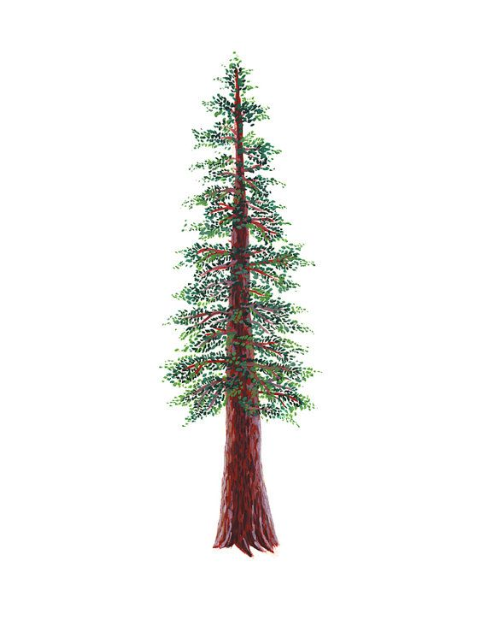
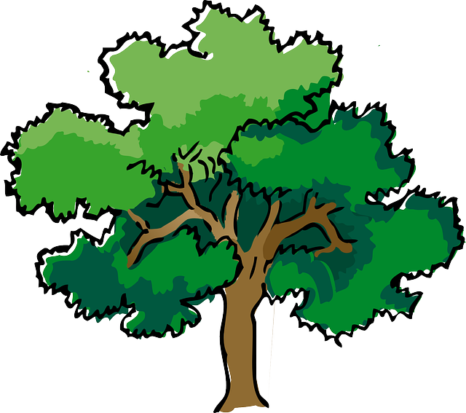
NORTH BAY LEAGUE GIRLS’ WRESTLING
ALL LEAGUE TEAM, 2022 – 2023

WRESTLER OF THE YEAR
137 | Jasmine Vo |  | 12 | Santa Rosa
FIRST TEAM
Wt. | First Name | Last Name | Grade | School
101 | Yerlin | Zavala-Cruz | 11 | Ukiah
106 | Bianca | Nelson | 11 | Rancho Cotate
111 | Shanty | Doherty | 9 | Ukiah
116 | Evelin | Cerda | 11 | Elsie Allen
121 | Mila | Martin | 9 | Montgomery
126 | Noelle | Alexander | 11 | Maria Carrillo
131 | Audrey | Lanzit | 12 | Ukiah
137 | Jasmine | Vo | 12 | Santa Rosa
143 | Sammy | Patton | 11 | Windsor
150 | Savannah | Nelsen | 10 | Ukiah
160 | Mia | Zaragozza | 11 | Windsor
170 | Jollette | Torres | 12 | Windsor
189 | Rawni | Self | 11 | Windsor
235 | Harbor | Ameperosa | 9 | Ukiah
SECOND TEAM
 | First Name | Last Name | Grade | School
101 | Kristi | Smith | 11 | Santa Rosa
106 | Alisha | Ontiveros | 10 | Windsor
111 | Kylie | Hernandez | 10 | Windsor
116 | Mannat | Kaur | 9 | Windsor
121 | Valondrah | Moth | 12 | Windsor
126 | Miako | Pizzorno | 10 | Windsor
131 | Catherine | Acevedo | 12 | Elsie Allen
137 | - | - |  | -
143 | Juliana | Montes | 9 | Montgomery
150 | Val | Martinez | 10 | Windsor
160 | Vanessa | Tepale | 11 | Ukiah
170 | Camila | Granado | 10 | Montgomery
189 | Marvella | Herrera | 9 | Ukiah
235 | Leslie | Rubio | 11 | Windsor
HONORABLE MENTION
Wt. | First Name | Last Name | Grade | School
101 | - | - | - | -
106 | Lilly | Stoner | 11 | Ukiah
111 | Kayci | Neal | 9 | Rancho Cotate
116 | Rikki | Vargas | 10 | Montgomery
121 | Rocio | Chavez-Fuentes | 11 | Ukiah
126 | Charlie | Devlin | 10 | Montgomery
131 | - | - |  | -
137 | - | - |  | -
143 | - | - |  | -
150 | Lindsey | Tyler | 10 | Montgomery
160 | - | - |  | -
170 | Grace | Rubio | 9 | Ukiah
189 | Daniela | Montes | 11 | Montgomery
235 | - | - |  | -

