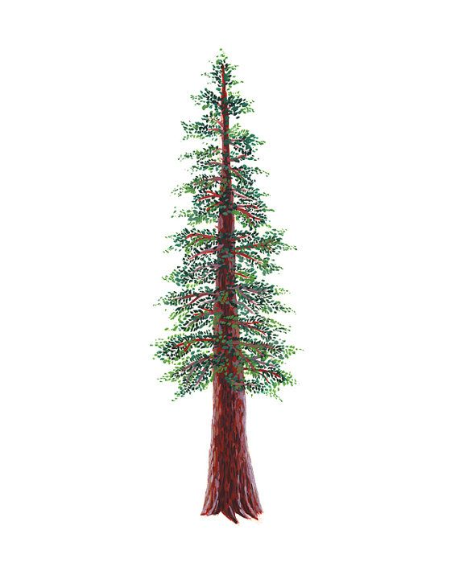
NORTH BAY LEAGUE BADMINTON SCHEDULE, 2023 – 2024
Redwood Division Revised 1/21/24
4:30pm start time (RCP 6:00pm)
TUESDAY MARCH 5 THURSDAY MARCH 28 TUESDAY APRIL 16
Windsor at Healdsburg Healdsburg at Windsor Windsor at Healdsburg
RUP at Elsie Allen Elsie Allen at RUP RUP at Elsie Allen
RCP Bye RCP Bye RCP Bye

THURSDAY MARCH 7 TUESDAY APRIL 2 WEDNESDAY APRIL 17
Windsor at RUP RUP at Windsor Windsor at RUP
RCP at Healdsburg Healdsburg at RCP RCP at Healdsburg
Elsie Allen Bye Elsie Allen Bye Elsie Allen Bye

TUESDAY MARCH 12 THURSDAY APRIL 4 THURSDAY APRIL 18
RUP at RCP RCP at RUP RCP at RUP
Elsie Allen at Windsor Windsor at Elsie Allen Elsie Allen at Windsor
Healdsburg Bye Healdsburg Bye Healdsburg Bye

THURSDAY MARCH 14 TUESDAY APRIL 9 TUESDAY APRIL 23
RCP at Elsie Allen Elsie Allen at RCP RCP at Elsie Allen
Healdsburg at RUP RUP at Healdsburg Healdsburg at RUP
Windsor Bye Windsor Bye Windsor Bye

TUESDAY MARCH 26 THURSDAY APRIL 11 THURSDAY APRIL 25
Elsie Allen at Healdsburg Healdsburg at Elsie Allen Elsie Allen at Healdsburg
RCP at Windsor Windsor at RCP RCP at Windsor
RUP Bye RUP Bye RUP Bye
IMPORTANT DATES
Pre-season coach meeting: | TBA
First day of practice: | Monday, February 5
Number of contests: | 24 matches  A maximum of two (2) scrimmages are permissible prior to the first interscholastic contest (league or non-league) of the season.
Match start time: | 4:30 pm
Seeding for NCS Qualifying Tourney and all-league meeting: | Monday, April 29, 5:30 PM, Santa Rosa High School
Singles tourney for NBL: | Tuesday, April 30, 4:30 PM at SRHS for D1; Piner for D2
Doubles tourney for NBL: | Wednesday, May 1 at 4:30 PM at Windsor for D1; Piner for D2
Mixed-doubles tourney for NBL: | Friday, May 3, 4:30 PM at Santa Rosa for D1; Piner for D2

NCS Championships
Deadline for leagues to determine qualifiers: May 4
Final date for competition other than NCS Championships: May 4
NCS Badminton Entries Deadline: May 5
NCS Badminton Bracket Development: May 5
NCS Championships: May 11
CIF D1 Nor-Cal Championship: May 18

