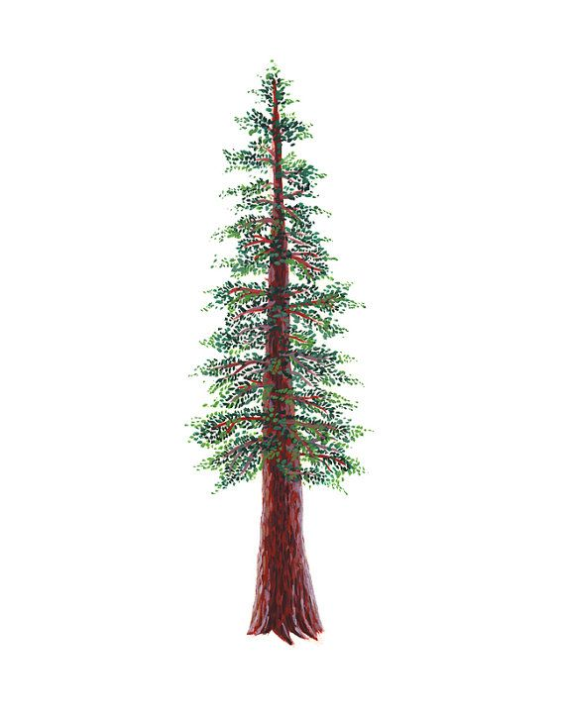
NORTH BAY LEAGUE REDWOOD DIVISION
Baseball Schedule 2022 – 2023
REVISED 5/30/22 TO INCLUDE ELSIE ALLEN HIGH SCHOOL AS A JV TEAM ONLY FOR 2023 SEASON.
Preseason coaches’ meeting: | TBA
All league selection meeting: | Tuesday, May 9, site and time TBD
First day of practice | Monday, February 6
Number of contests: | 24 contests. A maximum of two scrimmages are permissible prior to the first contest (league or non league) of the season.
Game start time: | 4:00 PM

Round 1 | Round 2 | Round 3
Friday, March 10  Montgomery at Healdsburg  Piner at Santa Rosa  St. Vincent at Elsie Allen | Tuesday, April 4  Healdsburg at Montgomery  Santa Rosa at Piner  Elsie Allen at St. Vincent | Thursday, April 20  St. Vincent at Santa Rosa  Montgomery at Piner  Healdsburg at Elsie Allen
Wednesday, March 15  Santa Rosa at Montgomery  Healdsburg at St. Vincent  Elsie Allen at Piner | Thursday, April 7  Montgomery at Healdsburg  Piner at Santa Rosa  St. Vincent at Elsie Allen | Wednesday, April 26  St Vincent at Piner  Healdsburg at Santa Rosa  Montgomery at Elsie Allen
Friday, March 17  St. Vincent at Santa Rosa  Montgomery at Piner  Healdsburg at Elsie Allen | Tuesday, April 11  Montgomery at Santa Rosa  St. Vincent at Healdsburg  Piner at Elsie Allen | Friday, April 28  Piner at St. Vincent  Santa Rosa at Healdsburg  Elsie Allen at Montgomery
Wednesday, March 29  Piner at St. Vincent  Santa Rosa at Healdsburg  Elsie Allen at Montgomery | Thursday, April 13  Santa Rosa at Montgomery  Healdsburg at St. Vincent  Elsie Allen at Piner | Wednesday, May 3  Piner at Healdsburg  Montgomery at St. Vincent  Elsie Allen at Santa Rosa
Friday, March 31  Healdsburg at Piner  St. Vincent at Montgomery  Santa Rosa at Elsie Allen | Tuesday, April 18  Santa Rosa at St. Vincent  Piner at Montgomery  Elsie Allen at Healdsburg | Friday, May 5  Healdsburg at Piner  St. Vincent at Montgomery  Santa Rosa at Elsie Allen
NBL CHAMPIONSHIPS
Wednesday, May 10: 1 at 4 and 2 at 3, site of highest seed
Friday, May 12: Winners at site of highest seed
NCS CHAMPIONSHP SERIES INFORMATION
Deadline for leagues to determine qualifiers: Friday, May 12
Final date for competition other than NCS Championships: Friday, May 12
NCS postseason applications due (automatic & at-larger): Friday, May 12, no later than 10 PM
At-large and seeding meeting: Saturday, May 13
Division 1, 3, 5 first round games: May 16
Division 2, 3, 6 first round games: May 17
Division 1, 3, 5 quarterfinal games: May 19
Division 2, 4 quarterfinal games, Division 6 semifinal games: May 20
Division 1, 3, 5 semifinal games: May 23
Division 2, 4 semifinal games: May 24
Division 1-6 NCS Championships: May 26 and 27
Nor-Cal Championships: May 30, June 1 and June 3
NCS Baseball Liaison: Sonjha Phillips, sphillips@cifncs.org

