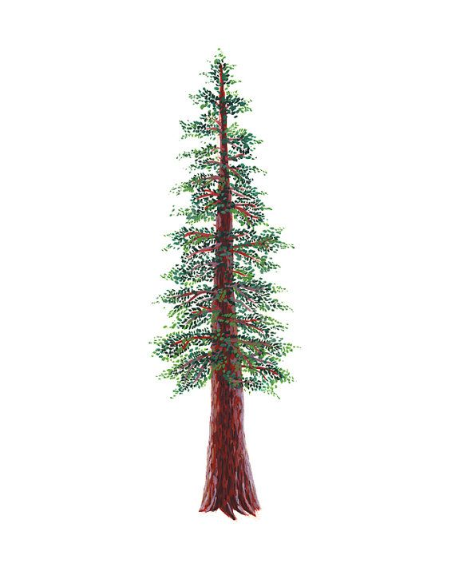
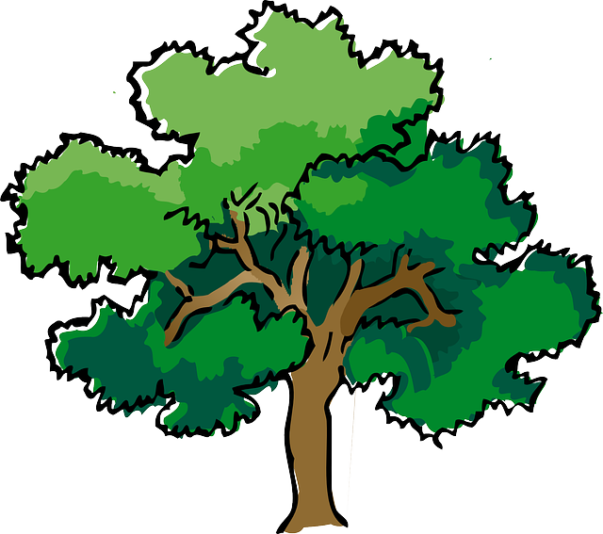
NORTH BAY LEAGUE
Wrestling Schedule, 2023 – 2024

Preseason meeting: | TBD
First day of practice: | Monday, October 30
Number of contests: | Maximum 40 matches. Two scrimmages are permissible prior to the first interscholastic contest (league or non-league) of the season.
Match time: | Start at 6 PM: JV boys, Varsity girls, Varsity boys
Weight Assessments begin: 10-15-23
2-pound growth allowance: 01-01-24
Weight Assessments end: 01-15-24
NCS Liaison for wrestling is Sonjha Phillips, email: sphillips@cifncs.org
OAK DIVISION |  | REDWOOD DIVISION
WEDNESDAY, JANUARY 10 |  | WEDNESDAY, JANUARY 10
Cardinal Newman at Healdsburg  Ukiah at Maria Carrillo  Elsie Allen at Windsor |  | Analy at St. Vincent’s  Rancho Cotate at Montgomery  Piner at Santa Rosa
WEDNESDAY, JANUARY 17 |  | WEDNESDAY, JANUARY 17
Healdsburg at Windsor  Maria Carrillo at Elsie Allen  Ukiah at Cardinal Newman |  | St. Vincent’s at Piner  Rancho Cotate at Analy  Montgomery at Santa Rosa
WEDNESDAY, JANUARY 24 |  | WEDNESDAY, JANUARY 24
Windsor / Cardinal Newman at Maria Carrillo  Healdsburg / Elsie Allen at Ukiah |  | Piner / Analy at Montgomery  Santa Rosa / St. Vincent at Rancho Cotate
WEDNESDAY, JANUARY 31 |  | WEDNESDAY, JANUARY 31
Elsie Allen at Cardinal Newman  Maria Carrillo at Healdsburg  Windsor at Ukiah |  | Montgomery at St. Vincent’s  Rancho Cotate at Piner  Santa Rosa at Analy
FRIDAY AND SATURDAY, FEBRUARY 9 AND 10
NBL Qualifying tournament for NCS Championships

BOYS AND GIRLS WRESTLING
Final date for competition other than league individual qualifying tournament or NCS and CIF Championships | January 31
Deadline for NBL to determine dual team qualifiers & at-large applications due | Jan. 31, 10 PM
Dual Team Competition (student competition) | February 3
NBL BOYS’ QUALIFIER TOURNAMENT SEEDING & GIRLS FINAL NBL TOURNEY SEEDING | February 7
Deadline for NBL to determine individual qualifiers | February 10
NCS GIRLS’ ENTRIES DUE | February 10, 5 PM
NCS BOYS’ ENTRIES DUE | February 10, 11:59 PM
NCS Seeding Meeting | February 11
NCS Championships | February 16 - 17
State CIF Championships | February 22 - 24

