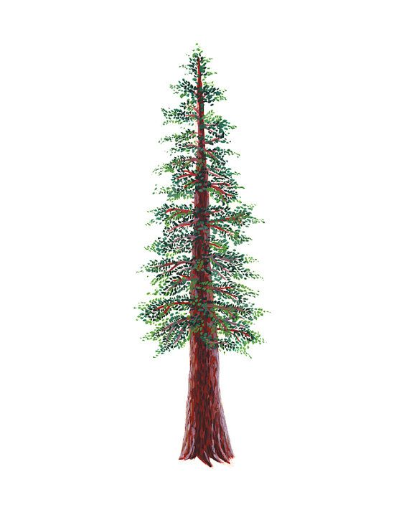
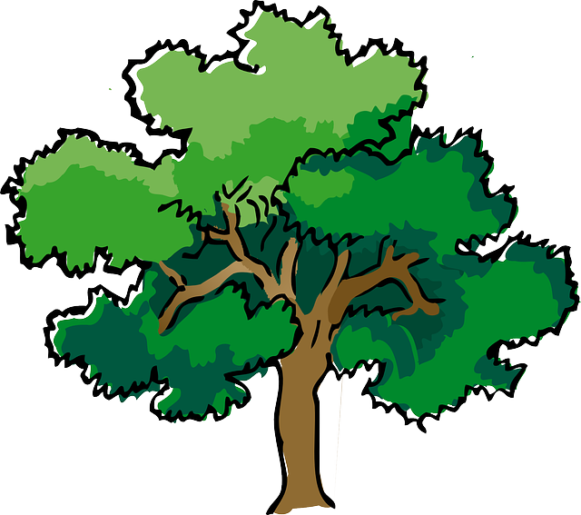
NORTH BAY LEAGUE
Wrestling Schedule, 2024 – 2025
Revised 3/9/24

Preseason meeting: | TBD
First day of practice: | Monday, November 4th
Number of contests: | Maximum 40 matches. Two scrimmages are permissible prior to the first interscholastic contest (league or non-league) of the season.
Match time: | Start at 6 PM: JV boys, Varsity girls, Varsity boys
Weight Assessments begin:
2-pound growth allowance:
Weight Assessments end:
NCS Liaison for wrestling is Sonjha Phillips, email: sphillips@cifncs.org
OAK DIVISION |  | REDWOOD DIVISION
WEDNESDAY, JANUARY 8 |  | WEDNESDAY, JANUARY 8
Ukiah at Cardinal Newman  Healdsburg at Montgomery  Windsor at Maria Carrillo |  | Piner at Analy  Elsie Allen at Rancho Cotate  Santa Rosa at St. Vincent
WEDNESDAY, JANUARY 15 |  | WEDNESDAY, JANUARY 15
Cardinal Newman at Healdsburg  Montgomery at Windsor  Maria Carrillo at Ukiah |  | Analy at Elsie Allen  Rancho Cotate at Santa Rosa  St. Vincent at Piner
WEDNESDAY, JANUARY 22 |  | WEDNESDAY, JANUARY 22
Healdsburg at Ukiah  Windsor at Cardinal Newman  Montgomery at Maria Carrillo |  | Elsie Allen at Piner  Santa Rosa at Analy  Rancho Cotate at St. Vincent
WEDNESDAY, JANUARY 29 |  | WEDNESDAY, JANUARY 29
Cardinal Newman at Maria Carrillo  Ukiah at Montgomery  Healdsburg at Windsor |  | Analy at St. Vincent  Piner at Rancho Cotate  Elsie Allen at Santa Rosa
WEDNESDAY, FEBRUARY 5 |  | WEDNESDAY, FEBRUARY 5
Ukiah at Windsor  Maria Carrillo at Healdsburg  Montgomery at Cardinal Newman |  | Piner at Santa Rosa  St. Vincent at Elsie Allen  Rancho Cotate at Analy
SATURDAY, FEBRUARY 15
NBL Qualifying tournament for NCS Championships

BOYS AND GIRLS WRESTLING
Final date for competition other than league individual qualifying tournament or NCS and CIF Championships | February 5th
Deadline for NBL to determine dual team qualifiers & at-large applications due | Feb. 5, 10 PM
Dual Team Competition (student competition) | February 8
NBL BOYS’ QUALIFIER TOURNAMENT SEEDING & GIRLS FINAL NBL TOURNEY SEEDING | February 12
Deadline for NBL to determine individual qualifiers | February 15
NCS GIRLS’ ENTRIES DUE | February 15, 5 PM
NCS BOYS’ ENTRIES DUE | February 15, 11:59 PM
NCS Seeding Meeting | February 16
NCS Championships | February 21 - 22
State CIF Championships | February 27 - 28, Mar. 1

