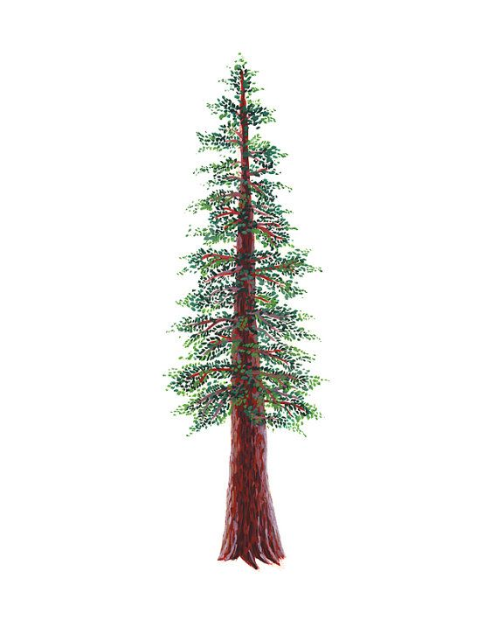
NORTH BAY LEAGUE REDWOOD DIVISION
GIRLS’ GOLF ALL-LEAGUE, 2021-2022

PLAYER OF THE YEAR

FIRST NAME | LAST NAME | GRADE | SCHOOL
Tehya | Mitchell | 9 | Healdsburg

FIRST TEAM

FIRST NAME | LAST NAME | GRADE | SCHOOL
Julie | Jenkins | 9 | Maria Carrllio
Alex | Negrevski | 10 | Maria Carrillo
Alex | Greene | 11 | Healdsburg
Kylie | Malm | 10 | Maria Carrillo

SECOND TEAM

FIRST NAME | LAST NAME | GRADE | SCHOOL
Angela | Creery | 9 | West County
Savanna | Conwell | 10 | West County
Lexi | Urbina | 11 | Ukiah
Ruby | Mortier | 11 | Ukiah

