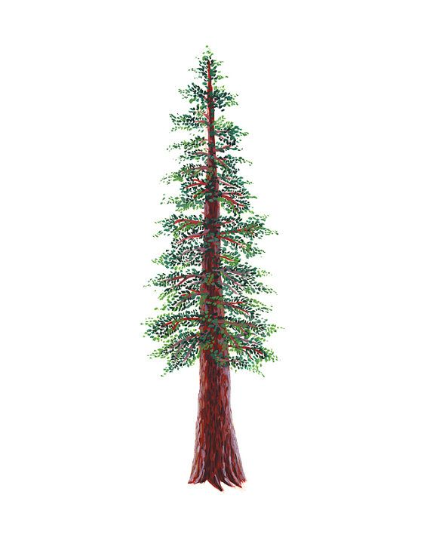
NORTH BAY LEAGUE
Girls’ Tennis Schedule, 2022 – 2023
(Year 1 of a two-year rotation)

Preseason Meeting: | Monday, August 1st 2022
First day of practice: | Monday, August 8
Number of contests: | 24 matches  A maximum of two scrimmages is permissible prior to the first interscholastic contest (league or non-league) of the season.
Tournaments: | Each match counts as one contest
Match start time: | 4:00 PM

THURSDAY, AUGUST 25  Rancho Cotate at Piner  Cardinal Newman at Windsor  Maria Carrillo at Montgomery  Healdsburg at Santa Rosa  Ukiah at West County  TUESDAY, AUGUST 30  Windsor at Rancho Cotate  Piner at Cardinal Newman  Healdsburg at Montgomery  Maria Carrillo at Ukiah  West County at Santa Rosa  THURSDAY, SEPTEMBER 1  Montgomery at Rancho Cotate  Maria Carrillo at Piner  Windsor at Ukiah  Santa Rosa at Cardinal Newman  West County at Healdsburg  TUESDAY, SEPTEMBER 6  Cardinal Newman at Rancho Cotate  Piner at Windsor  Santa Rosa at Montgomery  Ukiah at Healdsburg  Maria Carrillo at West County  THURSDAY, SEPTEMBER 8  Ukiah at Piner  Rancho Cotate at Santa Rosa  Healdsburg at Windsor  Cardinal Newman at Maria Carrillo  West County at Montgomery  TUESDAY, SEPTEMBER 13  Cardinal Newman at Ukiah  Windsor at Montgomery  Santa Rosa at Maria Carrillo  Healdsburg at Rancho Cotate  Piner at West County  THURSDAY, SEPTEMBER 15  Rancho Cotate at Maria Carrillo  Ukiah at Santa Rosa  Healdsburg at Piner  Cardinal Newman at Montgomery  Windsor at West County  TUESDAY, SEPTEMBER 20  Ukiah at Rancho Cotate  Piner at Montgomery  Maria Carrillo at Healdsburg  Santa Rosa at Windsor  Cardinal Newman at West County  THURSDAY, SEPTEMBER 22  Piner at Santa Rosa  Healdsburg at Cardinal Newman  Windsor at Maria Carrillo  Montgomery at Ukiah  West County at Rancho Cotate |  | TUESDAY, SEPTEMBER 27  Piner at Rancho Cotate  Windsor at Cardinal Newman  Montgomery at Maria Carrillo  Santa Rosa at Healdsburg  West County at Ukiah  THURSDAY, SEPTEMBER 29  Rancho Cotate at Windsor  Cardinal Newman at Piner  Montgomery at Healdsburg  Ukiah at Maria Carrillo  Santa Rosa at West County  TUESDAY, OCTOBER 4  Rancho Cotate at Montgomery  Piner at Maria Carrillo  Ukiah at Windsor  Cardinal Newman at Santa Rosa  Healdsburg at West County  THURSDAY, OCTOBER 6  Rancho Cotate at Cardinal Newman  Windsor at Piner  Montgomery at Santa Rosa  Healdsburg at Ukiah  West County at Maria Carrillo  TUESDAY, OCTOBER 11  Piner at Ukiah  Santa Rosa at Rancho Cotate  Windsor at Healdsburg  Maria Carrillo at Cardinal Newman  Montgomery at West County  THURSDAY, OCTOBER 13  Ukiah at Cardinal Newman  Montgomery at Windsor  Maria Carrillo at Santa Rosa  Rancho Cotate at Healdsburg  West County at Piner  THURSDAY, OCTOBER 18  Maria Carrillo at Rancho Cotate  Santa rosa at Ukiah  Piner at Healdsburg  Montgomery at Cardinal Newman  West County at Windsor  THURSDAY, OCTOBER 20  Rancho Cotate at Ukiah  Montgomery at Piner  Healdsburg at Maria Carrillo  Windsor at santa Rosa  West County at Cardinal Newman  TUESDAY, OCTOBER 25  Santa Rosa at Piner  Cardinal Newman at Healdsburg  Maria Carrillo at Windsor  Ukiah at Montgomery  Rancho Cotate at West County
Singles Tournament: Thursday, October 27 and Friday, October 28
Doubles Tournament: Wednesday, November 2 and Thursday, November 3
NCS/Les Schwab Tires Championships
Deadline for leagues to determine qualifiers in team tennis: November 5 (Team Tennis only)
Final date for team competition other than NCS Championships: November 5 (Team Tennis only)
NCS Postseason team applications due (automatic & at-large): November 5, 9 PM
At-large and seeding meeting for team tennis: November 6
Team Tennis Championships, Divisions 1 & 2: November 8, 10, 12
CIF Nor-Cal Team Tennis Championships: November 15*, 18-19
Deadline for leagues to determine qualifiers for singles/doubles: November 9
Final date for singles/doubles competition other than NCS Championships: November 9
NCS Postseason singles/doubles applications (automatic & at-large) due: November 9, 9 PM
Singles At-large Mtg.: November 10
Singles/Doubles Championships: November 14 – 15

