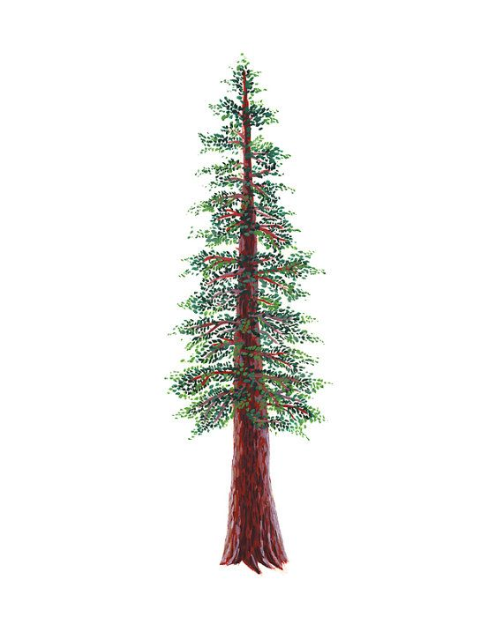
NORTH BAY LEAGUE REDWOOD DIVISION
GIRLS’ VOLLEYBALL ALL-LEAGUE, 2021-2022

CO PLAYERS OF THE YEAR

TEAGAN IRISH (MIDDLE HITTER) RANCHO COTATE
MARITZA PEREZ (SETTER/OUTSIDE HITTER) PINER

FIRST TEAM

FIRST NAME | LAST NAME | GRADE | SCHOOL
Kylie | Lopes (Libero) | 11 | Rancho Cotate
Abby | Johnson (Setter/Opposite) | 10 | Rancho Cotate
Taylor | Melland (Middle Hitter) | 11 | Rancho Cotate
Naomi | Lunceford (Outside Hitter) | 12 | Ukiah
Sophia | Dunnicliff (Outside Hitter, setter) | 12 | Ukiah
Zoey | White (Libero) | 12 | Ukiah
Teresa | Helfrick (Outside Hitter) | 11 | Healdsburg
Sophia | Skubic (Setter/Middle Hitter) | 12 | St. Vincent

SECOND TEAM

FIRST NAME | LAST NAME | GRADE | SCHOOL
Keyonee | Neal (Outside Hitter) | 12 | Rancho Cotate
Angie | Gomez-Dias (Setter) | 12 | Rancho Cotate
Mckenna | Bird (Setter) | 10 | Ukiah
Julia | Maldonaldo (Setter) | 12 | Ukiah
Emory | Joy (Middle Hitter) | 11 | Healdsburg
Lizette | Gomez (Setter) | 11 | Healdsburg
Ava | Sullivan (Outside Hitter) | 10 | St. Vincent
Danae | Martin (Middle Hitter/Opposite) | 12 | Piner

