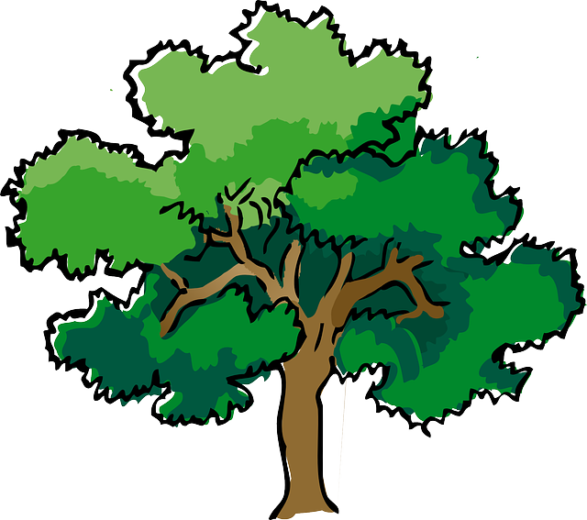
NORTH BAY LEAGUE OAK DIVISION
BOYS’ BASKETBALL ALL-LEAGUE, 2022 - 2023

AWARDS OF MERIT
Sam Cline | 12 | Cardinal Newman | Co-Most Valuable Player
Finn Grace | 12 | Windsor | Co-Most Valuable Player
Gavin Vogensen | 12 | Cardinal Newman | Defensive Player of the Year

FIRST TEAM
First Name | Last Name | Grade | School
Jayden | Russotti | 12 | Windsor
Gavin | Vogensen | 12 | Cardinal Newman
Andrew | Krilich | 12 | Cardinal Newman
Donovan | Hawkins | 12 | Montgomery
Caden | DeVries | 11 | Montgomery
Dave | Baraka | 12 | Piner
SECOND TEAM
First Name | Last Name | Grade | School
Gavin | Reid | 12 | Analy
Hayden | Anderson | 10 | Windsor
Izeyah | Wright | 11 | Montgomery
Elijah | Hansen | 11 | Santa Rosa
Kansh | Singh | 12 | Piner
HONORABLE MENTION
First Name | Last Name | Grade | School
Cooper | Wood | 12 | Maria Carrillo
Will | Grafe | 11 | Montgomery
Matt | Erickson | 11 | Piner
Theo | McDowell | 11 | Piner
Mahdi | Camara | 10 | Cardinal Newman
Colin | Kraft | 11 | Windsor

Co-Coaches of the year:
Travis Taylor - Cardinal Newman, Steve Kramer- Windsor

