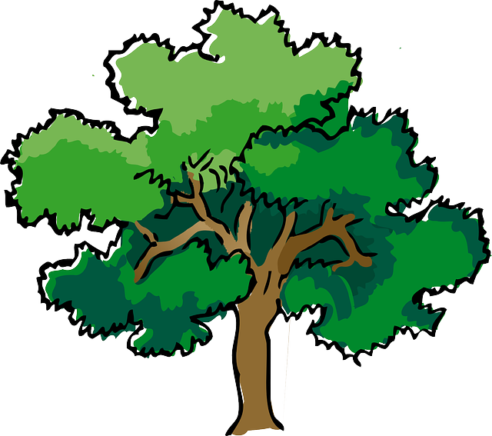
NORTH BAY LEAGUE OAK DIVISION
Girls’ Basketball Schedule 2023 – 2024
Revised 4/7/23

Preseason coaches’ meeting: |  | Wednesday, Oct. 25, 7 PM Cardinal Newman ACC
First day of practice |  | Monday, October 30
Number of contests: |  | 26; 2 scrimmages are permissible prior to the first interscholastic contest (league or non-league) of the season.
Foundation Games: |  | November 21
Post-season/all-league selection meeting: |  | TBD
Game start times: |  | 4:30 (Freshmen); 6:00 (JV); 7:30 PM (Varsity)
THURSDAY, JANUARY 4 |  |  |  | WEDNESDAY, JANUARY 24
 | Ukiah at Analy |  |  |  | Analy at Ukiah
 | Cardinal Newman at Maria Carrillo |  |  |  | Maria Carrillo at Cardinal Newman
 | Montgomery bye |  |  |  | Montgomery bye
WEDNESDAY, JANUARY 10 |  |  |  | FRIDAY, JANUARY 26
 | Maria Carrillo at Ukiah |  |  |  | Ukiah at Maria Carrillo
 | Montgomery at Cardinal Newman |  |  |  | Cardinal Newman at Montgomery
 | Analy bye |  |  |  | Analy bye
FRIDAY, JANUARY 12 |  |  |  | TUESDAY, JANUARY 30
 | Analy at Maria Carrillo |  |  |  | Maria Carrillo at Analy
 | Ukiah at Montgomery |  |  |  | Montgomery at Ukiah
 | Cardinal Newman bye |  |  |  | Cardinal Newman bye
TUESDAY, JANUARY 16 |  |  |  | THURSDAY, FEBRUARY 1
 | Cardinal Newman at Analy |  |  |  | Analy at Cardinal Newman
 | Montgomery at Maria Carrillo |  |  |  | Maria Carrillo at Montgomery
 | Ukiah Bye |  |  |  | Ukiah Bye
THURSDAY, JANUARY 18 |  |  |  | SATURDAY, FEBRUARY 3
 | Montgomery at Analy |  |  |  | Analy at Montgomery
 | Ukiah at Cardinal Newman |  |  |  | Cardinal Newman at Ukiah
 | Maria Carrillo Bye |  |  |  | Maria Carrillo Bye

NCS Championships
NBL tournament semi-finals: Tuesday, February 7 (Site of highest seed), NBL tournament finals: February 9
Final date for leagues to determine qualifiers: February 10
Final date for competition other than NCS Championships: February 10
NCS postseason applications due (automatic and at-large): February 10, 10 PM
NCS At-large and seeding meeting: February 11
Division 1-3-5 first-round games: February 13, Division 2-4-6 first-round games: February 14
Open Division first-round games: February 15
Division 1-3-5 quarterfinal round games: February 16, Division 2-4-6 quarterfinal round games: February 17
Division 1-3-5 semifinal games: February 20
Open Division, Division 2-4-6 semifinal games: February 21, Open Division, Division 1-6 NCS Championship games: February 23 - 24
Northern California Championships: Feb. 27,28,29, March 2, 5
CIF State Championship: March 8-9

