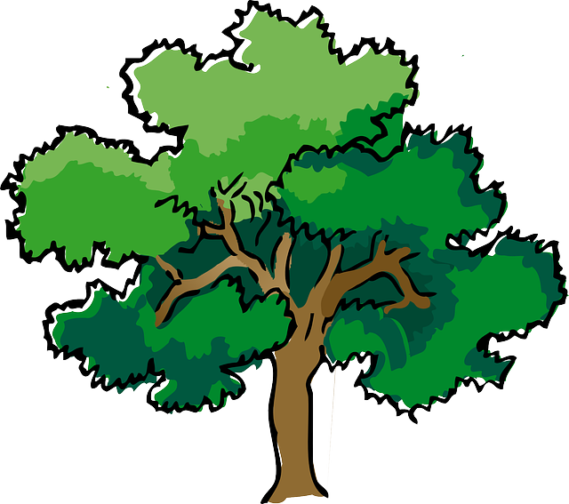
NORTH BAY LEAGUE OAK DIVISION
Girls’ Basketball Schedule 2024-2025
Revised 4/2/24

Preseason coaches’ meeting: |  | Wednesday, TBD, 7 PM Cardinal Newman ACC
First day of practice |  | Monday, November 4, 2024
Number of contests: |  | 26; 2 scrimmages are permissible before the season's first interscholastic contest (league or non-league).
Foundation Games: |  | November 26, 2024
Post-season/all-league selection meeting: |  | TBD
Game start times: |  | 4:30 (Freshmen); 6:00 (JV); 7:30 PM (Varsity)
TUESDAY, JANUARY 7 |  |  |  | THURSDAY, JANUARY 23
 | Cardinal Newman at Windsor |  |  |  | Windsor at Cardinal Newman
 | Maria Carrillo at Montgomery |  |  |  | Montgomery at Maria Carrillo
 | Analy at Rancho Cotate |  |  |  | Rancho Cotate at Analy
THURSDAY, JANUARY 9 |  |  |  | WEDNESDAY, JANUARY 29
 | Windsor at Maria Carrillo |  |  |  | Maria Carrillo at Windsor
 | Montgomery at Analy |  |  |  | Analy at Montgomery
 | Rancho Cotate at Cardinal Newman |  |  |  | Cardinal Newman at Rancho Cotate
TUESDAY, JANUARY 14 |  |  |  | FRIDAY, JANUARY 31
 | Maria Carrillo at Cardinal Newman |  |  |  | Cardinal Newman at Maria Carrillo
 | Analy at Windsor |  |  |  | Windsor at Analy
 | Montgomery at Rancho Cotate |  |  |  | Rancho Cotate at Montgomery
THURSDAY, JANUARY 16 |  |  |  | WEDNESDAY, FEBRUARY 5
 | Windsor at Rancho Cotate |  |  |  | Rancho Cotate at Windsor
 | Cardinal Newman at Montgomery |  |  |  | Montgomery at Cardinal Newman
 | Maria Carrillo at Analy |  |  |  | Analy at Maria Carrillo
TUESDAY, JANUARY 21 |  |  |  | FRIDAY, FEBRUARY 7
 | Analy at Cardinal Newman |  |  |  | Cardinal Newman at Analy
 | Rancho Cotate at Maria Carrillo |  |  |  | Maria Carrillo at Rancho Cotate
 | Montgomery at Windsor |  |  |  | Windsor at Montgomery

NCS Championships
NBL tournament semi-finals: Tuesday, February 11 (Site of highest seed), NBL tournament finals: Saturday, February 15
Final date for leagues to determine qualifiers: February 15
Final date for competition other than NCS Championships: February 15
NCS postseason applications due (automatic and at-large): February 15, 10 PM
NCS At-large and seeding meeting: February 16
Division 1-3-5 first-round games: February 18, Division 2-4-6 first-round games: February 19
Open Division first-round games: February 20
Division 1-3-5 quarterfinal round games: February 21, Division 2-4-6 quarterfinal round games: February 22
Division 1-3-5 semifinal games: February 25
Open Division, Div 2-4-6 semifinal games: February 26, Open Div, Division 1-6 NCS Championship games: February 28 - March 1
Northern California Championships: March 4,5,6,8,11
CIF State Championship: March 14-15

