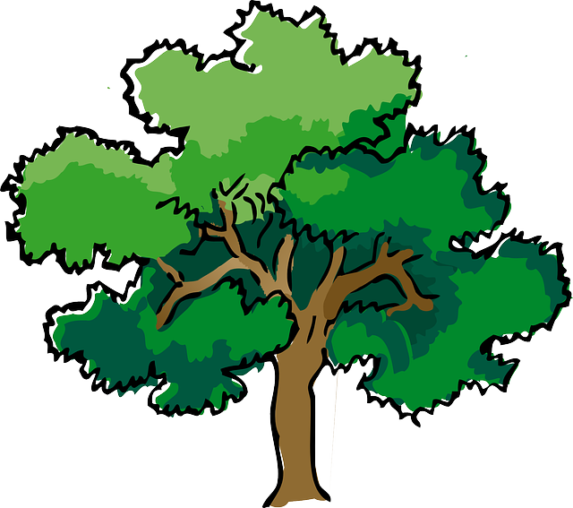
NORTH BAY LEAGUE OAK DIVISION
Swimming & Diving Schedule, 2022 – 2023
REVISED 2/1/23

Preseason Meeting: | TBD
First day of practice: | Monday, February 6
Number of contests: | 14 meets. Two (2) scrimmages are permissible prior to the first contest (league or nonleague) of the season. Each meet counts as one contest.
Meet time: | Ives: 3/3:30; Finley: 2/2:30; Ridgway, 2/2:30; Rancho, 2/2:30; Healdsburg, 3:30/4; Cardinal Newman, 3/3:30

WEDNESDAY, MARCH 1 | TUESDAY, APRIL 4
Maria Carrillo at Montgomery (TBD) | Montgomery at Maria Carrillo (TBD)
Cardinal Newman bye | Cardinal Newman bye
Santa Rosa at Ukiah (Ukiah) | Ukiah at Santa Rosa (TBD)
WEDNESDAY, MARCH 8 | THURSDAY, APRIL 6
Santa Rosa at Maria Carrillo (TBD) | Maria Carrillo at Santa Rosa (TBD)
Montgomery at Cardinal Newman (SRJC) | Cardinal Newman at Montgomery (TBD)
Ukiah Bye | Ukiah bye
TUESDAY, MARCH 14 | TUESDAY, APRIL 11
Maria Carrillo at Ukiah (Ukiah) | Ukiah at Maria Carrillo (TBD)
Cardinal Newman at Santa Rosa (TBD) | Santa Rosa at Cardinal Newman (SRJC)
Montgomery bye | Montgomery bye
THURSDAY, MARCH 16 | THURSDAY, APRIL 13
Santa Rosa bye | Santa Rosa bye
Ukiah at Montgomery (TBD) | Montgomery at Ukiah
Maria Carrillo at Cardinal Newman (SRJC) | Cardinal Newman at Maria Carrillo (TBD)
WEDNESDAY, MARCH 29 | WEDNESDAY, APRIL 19
Ukiah at Cardinal Newman (SRJC) | Cardinal Newman at Ukiah (Ukiah)
Maria Carrillo bye | Maria Carrillo bye
Montgomery at Santa Rosa (TBD) | Santa Rosa at Montgomery (TBD)

NBL AND NCS CHAMPIONSHIP INFORMATION
March 4: | Santa Rosa Junior College High School Invitational
April 24: | Deadline for NBL meet qualifiers
April 26: | NBL Qualifying Championship seeding, 7 PM
April 28: | Championship prelims; warm-up, 11 – 11:45; start at 12 PM
April 29: | Championship finals; warm-up, 8 – 8:45; Meet starts at 9
April 29: | Deadline for leagues to determine qualifiers
April 29: | Final date for competition other than NCS Championships
April 30: | NCS entries due by 1:15 PM
May 1: | Seeding meeting
May 4: | *Diving Championship
May 5: | *Swimming trials
May 6: | Swimming Championships
May 11-13: | CIF State Championships
*When the venue for the swimming and diving championship allows both activities to be held in the same location, the diving championships will be held on the same day as the swimming trials.

