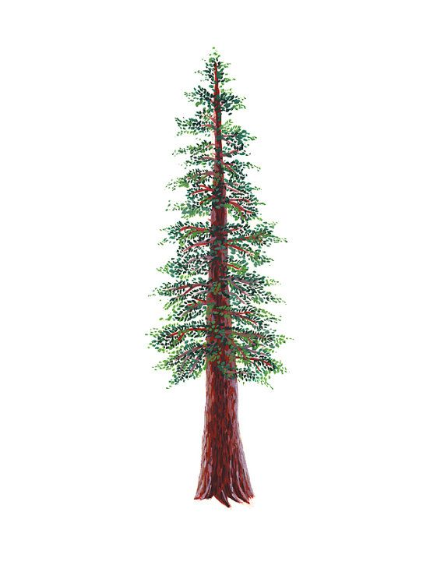

NBL ALL-LEAGUE BADMINTON, 2022 – 2023
Redwood

PLAYERS OF THE YEAR
First Name | Last Name | Grade | School
Diego | Rodriguez | 10 | Healdsburg
Sabrina | Hall | 12 | Analy
BOYS SINGLES
First Name | Last Name | Grade | School
Diego | Rodriguez | 10 | Healdsburg
Jaylin | Dyleski | 11 | Analy
Julian | Kolodziejczyk | 11 | Analy
Juan | Rios | 12 | Roseland University Prep
GIRLS SINGLES
First Name | Last Name | Grade | School
Sabrina | Hall | 12 | Analy
Bella | Gee | 9 | Analy
Citlaly | Rosillo | 12 | Healdsburg
Blanca | Pulido | 11 | Elsie Allen
BOYS DOUBLES
Names |  |  | School
Juanes Rios (12) and Francisco De La Luz (12) |  |  | Roseland University Prep
Andy Duran (10) and David Negrete (11) |  |  | Healdsburg
GIRLS DOUBLES
Names |  |  | School
Jade Glentzer (12) and Uma Anandakuttan (10) |  |  | Analy
Hawaii Thao (9) and Amanpreet Kaur (11) |  |  | Elsie Allen

MIXED DOUBLES
Names | School
Julian Kolodziejczyk (11) and Sabrina Hall (12) | Analy
Edsel Valdez (12) and Citlaly Rosillo (12) | Healdsburg
Diego Rodriguez (10) and Kathleen Casero (9) | Healdsburg

SECOND TEAM
First Name | Last Name | Grade | School
Triniti | Dominguez | 12 | Roseland University Prep

