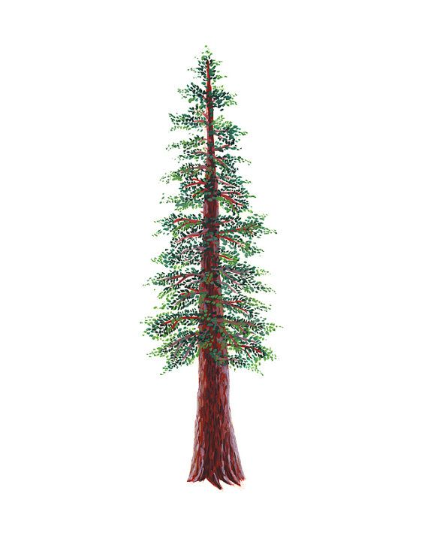
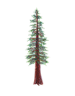
NORTH BAY LEAGUE,
REDWOOD DIVISION
BOYS’ GOLF ALL-LEAGUE, 2021– 2022

PLAYERS OF THE YEAR
Kaden Thurston | 12 | Ukiah

FIRST TEAM
First Name | Last Name | Grade | School
Jack | Selvage | 11 | Rancho Cotate
Hudson | Stipp | 10 | St. Vincent de Paul
Logan | Christian | 9 | Rancho Cotate
Addison | Keohn | 10 | Ukiah

SECOND TEAM
First Name | Last Name | Grade | School
Owen | Behrens | 11 | Healdsburg
Harjot | Singh | 12 | Piner
Baylor | Barrett | 12 | Ukiah
Jaden | Gragg | 12 | Rancho Cotate

