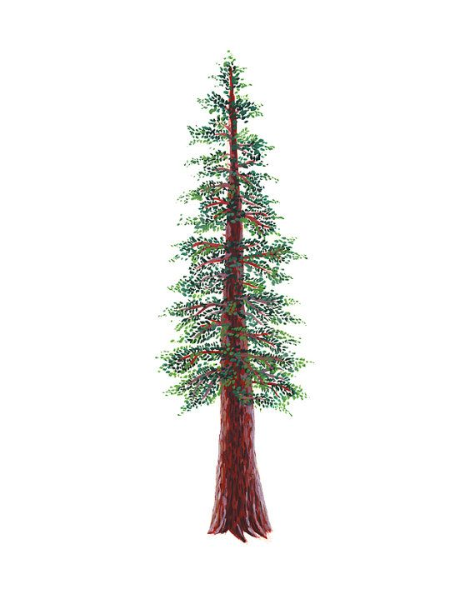
NORTH BAY LEAGUE REDWOOD DIVISION
Girls’ Golf Schedule, 2023 – 2024
(Year 2 of a two-year rotation)

Preseason Meeting: | TBA
First day of practice: | Monday, Aug 7, 2023
Number of contests: | 22 matches; no scrimmages; double-round robin, 9 hole matches
Tournaments: | Each match counts as one contest
Match start time: | TBD

Tuesday, September 12  Ukiah at Maria Carrillo  Analy at Healdsburg | Thursday, September 28  9 Hole Mini Tournament@ Healdsburg (Tayman)  Ukiah, Maria Carrillo, Analy, Healdsburg
Thursday, September 14  Maria Carrillo at Healdsburg  Ukiah at Analy | Tuesday, October 3  Healdsburg at Maria Carrillo  Analy at Ukiah
Tuesday, September 19  Healdsburg at Ukiah  Analy at Maria Carrillo | Thursday, October 5  9 Hole Mini Tournament @ Analy (SRGCC)  Ukiah, Maria Carrillo, Analy, Healdsburg
Thursday, September 21  9 Hole Mini Tournament@ Ukiah (Ukiah)  Ukiah, Maria Carrillo, Analy, Healdsburg | Tuesday October 10  Ukiah at Healdsburg  Maria Carrillo at Analy
Tuesday, September 26  Maria Carrillo at Ukiah  Healdsburg at Analy | Thursday, October 12  9 Hole Mini Tournament@ M.C. (Sugarloaf)  Ukiah, Maria Carrillo, Analy, Healdsburg
NCS Singles Qualifying Tournament: Monday, October 16 at Rooster Run; host TBD

NCS/Les Schwab Tires Championships
Deadline for leagues to determine qualifiers: Tuesday, October 17
Automatic league qualifier entries and at-large applications due no later than 8 PM on October 17; forms available at www.cifncs.org
At-large meeting: Wednesday, October 18 (NCS Committee, coaches do not attend)
Division 2 Championship/Individual Qualifier (pending course availability: Monday, October 23
Division 1 Championship (pending course availability): Monday, October 30st
Northern California Golf Championships: Monday, November 6; course to be determined
CIF State Championships: Wednesday, November 15; course to be determined

CIF Bylaw 504m (SUNDAY RESTRICTIONS) In order to provide at least one day of respite from involvement in interscholastic athletics each week, no interscholastic games or practices of any kind are to be held on Sunday.

