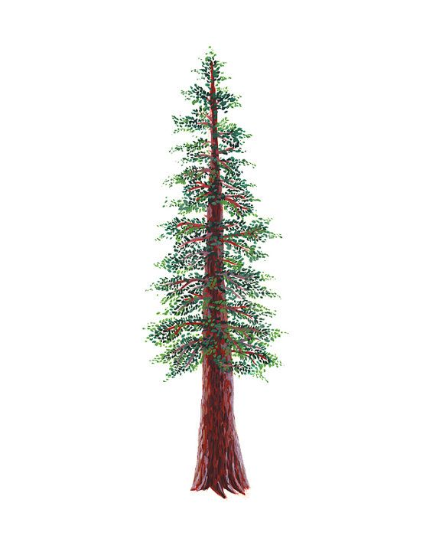
NORTH BAY LEAGUE REDWOOD DIVISION
Girls’ Golf Schedule, 2024 – 2025
(Year 1 of a two-year rotation)
Updated 12/12/23
Preseason Meeting: | TBA
First day of practice: | Monday, Aug 12, 2024
Number of contests: | 22 matches; no scrimmages; double-round robin, 9 hole matches
Tournaments: | Each match counts as one contest
Match start time: | TBD

Tuesday, September 17  Montgomery at Maria Carrillo  Ukiah at Healdsburg | Thursday, October 3  9 Hole Mini Tournament@ Healdsburg (Tayman)  Ukiah, Maria Carrillo, Montgomery, Healdsburg
Thursday, September 19  Healdsburg at Montgomery  Maria Carrillo at Ukiah | Tuesday, October 8  Montgomery at Healdsburg  Ukiah at Maria Carrillo
Tuesday, September 24  Healdsburg at Maria Carrillo  Montgomery at Ukiah | Thursday, October 10  9 Hole Mini Tournament @ (TBA)  Ukiah, Maria Carrillo, Montgomery, Healdsburg
Thursday, September 26  9 Hole Mini Tournament@ Ukiah (Ukiah)  Ukiah, Maria Carrillo, Montgomery, Healdsburg | Tuesday, October 15  Maria Carrillo at Healdsburg  Ukiah at Montgomery
Tuesday, October 1  Maria Carrillo at Montgomery  Healdsburg at Ukiah | Thursday, October 17  9 Hole Mini Tournament@ M.C. (Sugarloaf)  Ukiah, Maria Carrillo, Montgomery, Healdsburg

NCS Singles Qualifying Tournament: Monday, October 21 at Rooster Run 12:00pm; host TBD
NCS/Les Schwab Tires Championships
Deadline for leagues to determine qualifiers: Tuesday, October 22
Automatic league qualifier entries and at-large applications are due no later than 8 PM on October 22; forms available at www.cifncs.org
At-large meeting: Wednesday, October 23 (NCS Committee, coaches do not attend)
Division 2 Championship/Individual Qualifier (pending course availability: Monday, October 28
Division 1 Championship (pending course availability): Monday, November 4th
Northern California Golf Championships: Monday, November 11; course to be determined
CIF State Championships: Wednesday, November 20; course to be determined

CIF Bylaw 504m (SUNDAY RESTRICTIONS) In order to provide at least one day of respite from involvement in interscholastic athletics each week, no interscholastic games or practices of any kind are to be held on Sunday.

