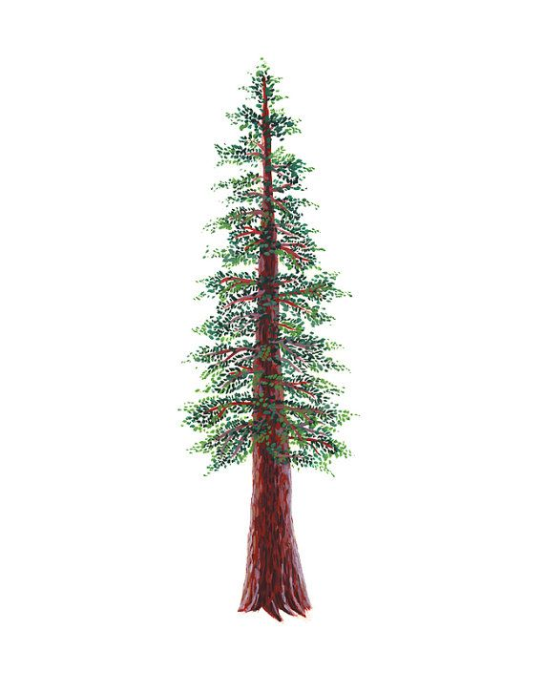
NORTH BAY LEAGUE REDWOOD DIVISION
Softball Schedule, 2022 – 2023
Revised 9/9/22

Preseason coaches’ meeting: | TBD
First day of practice | February 6
Number of contests: | 24 games. A maximum of two scrimmages are permissible prior to the first contest (league or non-league) of the season.
Spring Break: | March 20 - 24
All-league selection mtg.: | Monday, May 8, site and time TBD
Game start time: | 4:00 PM

THURSDAY, MARCH 9 | TUESDAY, APRIL 4 | THURSDAY, APRIL 20
Ukiah at St. Vincent | St. Vincent at Ukiah | Ukiah at St. Vincent
Piner at Santa Rosa | Santa Rosa at Piner | Piner at Santa Rosa
Elsie Allen at Healdsburg | Healdsburg at Elsie Allen | Elsie Allen at Healdsburg
TUESDAY, MARCH 14 | THURSDAY, APRIL 6 | TUESDAY, APRIL 25
St. Vincent at Piner | Piner at St. Vincent | St. Vincent at Piner
Santa Rosa at Elsie Allen | Elsie Allen at Santa Rosa | Santa Rosa at Elsie Allen
Healdsburg at Ukiah | Ukiah at Healdsburg | Healdsburg at Ukiah
THURSDAY, MARCH 16 | TUESDAY, APRIL 11 | THURSDAY, APRIL 27
Piner at Ukiah | Ukiah at Piner | Piner at Ukiah
Elsie Allen at St. Vincent | St. Vincent at Elsie Allen | Elsie Allen at St. Vincent
Santa Rosa at Healdsburg | Healdsburg at Santa Rosa | Santa Rosa at Healdsburg
TUESDAY, MARCH 28 | THURSDAY, APRIL 13 | TUESDAY, MAY 2
Santa Rosa at Ukiah | Healdsburg at St. Vincent | Santa Rosa at Ukiah
Piner at Elsie Allen | Ukiah at Santa Rosa | Piner at Elsie Allen
St. Vincent at Healdsburg | Elsie Allen at Piner | St Vincent at Healdsburg
THURSDAY, MARCH 30 | TUESDAY, APRIL 18 | THURSDAY, MAY 4
Ukiah at Elsie Allen | Elsie Allen at Ukiah | Ukiah at Elsie Allen
Healdsburg at Piner | Piner at Healdsburg | Healdsburg at Piner
St. Vincent at Santa Rosa | Santa Rosa at St. Vincent | St. Vincent at Santa Rosa

NBL CHAMPIONSHIPS
Tuesday, May 9, 4 at 1and 3 at 2 (site of highest seed)
Thursday, May 11: Winners at site of highest seed

NCS CHAMPIONSHIP SERIES INFORMATION
Deadline for leagues to determine qualifiers: Friday, May 12
Final date for competition other than NCS Championships: Friday, May 12
NCS postseason applications due (automatic & at-larger): Friday, May 12, no later than 10 PM
At-large and seeding meeting: Saturday, May 13
Division 1 – 6, first round games: May 16 - 17
Division 1 – 5, quarterfinal games/Division 6 semifinal games: May 19 - 20
Division 2, 4 quarterfinal games, Division 6 semifinal games: May 20
Division 1 – 5, semifinal games: May 23 - 24
Division 1-6 NCS Championships: May 26 and 27
Nor-Cal Championships: May 30, June 1 and June 3

NCS Softball liaison: Bri Niemi, bniemi@cifncs.org

