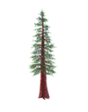
NORTH BAY LEAGUE REDWOOD DIVISION
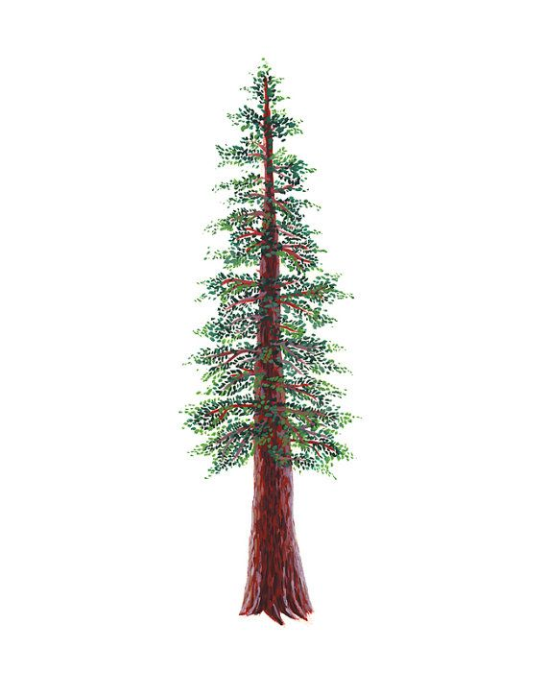
Swimming & Diving Schedule, 2022 – 2023
REVISED 2/1/23

Preseason Meeting: | TBD
First day of practice: | Monday, February 6
Number of contests: | 14 meets. Two (2) scrimmages are permissible prior to the first contest (league or nonleague) of the season. Each meet counts as one contest.
Meet time: | Ives: 3/3:30; Finley: 2/2:30; Ridgway, 2/2:30; Rancho, 2/2:30; Healdsburg, 3:30/4; Cardinal Newman, 3/3:30

WEDNESDAY, MARCH 1 | TUESDAY, APRIL 4
Healdsburg at Piner (TBD) | Piner at Healdsburg
Analy bye | Analy bye
Rancho Cotate at Windsor (Healdsburg) | Windsor at Rancho Cotate
WEDNESDAY, MARCH 8 | THURSDAY, APRIL 6
Rancho Cotate at Healdsburg | Healdsburg at Rancho Cotate
Piner at Analy (Ives) | Analy at Piner (TBD)
Windsor Bye | Windsor bye
TUESDAY, MARCH 14 | TUESDAY, APRIL 11
Healdsburg at Windsor (Healdsburg) | Windsor at Healdsburg
Analy at Rancho Cotate | Rancho Cotate at Analy (Ives)
Piner bye | Piner bye
THURSDAY, MARCH 16 | THURSDAY, APRIL 13
Rancho Cotate bye | Rancho Cotate bye
Piner at Windsor (Healdsburg) | Windsor at Piner (TBD)
Healdsburg at Analy (Ives) | Analy at Healdsburg
WEDNESDAY, MARCH 29 | WEDNESDAY, APRIL 19
Windsor at Analy (Ives) | Analy at Windsor (Healdsburg)
Healdsburg bye | Healdsburg bye
Piner at Rancho Cotate | Rancho Cotate at Piner (TBD)

NBL AND NCS CHAMPIONSHIP INFORMATION
March 4: | Santa Rosa Junior College High School Invitational
April 24: | Deadline for NBL meet qualifiers
April 26: | NBL Qualifying Championship seeding, 7 PM
April 28: | Championship prelims; warm-up, 11 – 11:45; start at 12 PM
April 29: | Championship finals; warm-up, 8 – 8:45; Meet starts at 9
April 29: | Deadline for leagues to determine qualifiers
April 29: | Final date for competition other than NCS Championships
April 30: | NCS entries due by 1:15 PM
May 1: | Seeding meeting
May 4: | *Diving Championship
May 5: | *Swimming trials
May 6: | Swimming Championships
May 11-13: | CIF State Championships
*When the venue for the swimming and diving championship allows both activities to be held in the same location, the diving championships will be held on the same day as the swimming trials.

