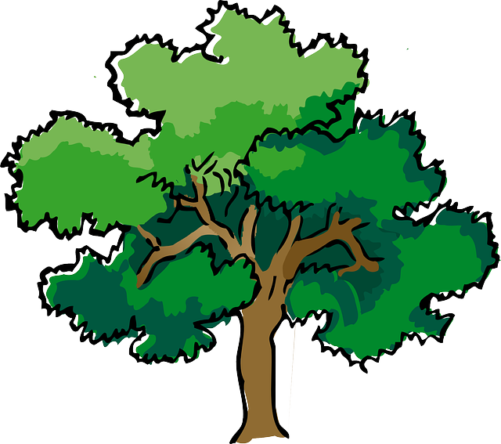
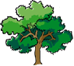
NORTH BAY LEAGUE OAK DIVISION
Swimming & Diving Schedule, 2023 – 2024
REVISED 10/6/23

Preseason Meeting: | TBD
First day of practice: | Monday, February 5
Number of contests: | 14 meets. Two (2) scrimmages are permissible prior to the first contest (league or non league) of the season. Each meet counts as one contest.
Meet time: | Ives: 3/3:30; Finley: 2/2:30; Ridgway, 2/2:30; Rancho, 2/2:30; Healdsburg, 3:30/4; Cardinal Newman, 3/3:30

WEDNESDAY, FEBRUARY 28 | TUESDAY, APRIL 2
Montgomery at Maria Carrillo (TBD) | Maria Carrillo at Montgomery (TBD)
Cardinal Newman bye | Cardinal Newman bye
 | Santa Rosa at Ukiah (Ukiah)
THURSDAY, FEBRUARY, 29
Ukiah at Santa Rosa(TBA)

WEDNESDAY, MARCH 6 | THURSDAY, APRIL 4
Maria Carrillo at Santa Rosa (TBD) | Santa Rosa at Maria Carrillo (TBD)
Ukiah Bye | Montgomery at Cardinal Newman (SRJC)
THURSDAY, MARCH 7  Cardinal Newman at Montgomery (TBA) | Ukiah bye
TUESDAY, MARCH 12 | TUESDAY, APRIL 9
Ukiah at Maria Carrillo (TBA) | Maria Carrillo at Ukiah (Ukiah)
Santa Rosa at Cardinal Newman (SRJC) | Cardinal Newman at Santa Rosa (TBA)
Montgomery bye | Montgomery bye
THURSDAY, MARCH 14 | THURSDAY, APRIL 11
Santa Rosa bye | Santa Rosa bye
Montgomery at Ukiah (Ukiah) | Ukiah at Montgomery (TBA)
Cardinal Newman at Maria Carrillo (TBA) | Maria Carrillo at Cardinal Newman (SRJC)
WEDNESDAY, MARCH 27 | WEDNESDAY, APRIL 17
Cardinal Newman at Ukiah (Ukiah) | Ukiah at Cardinal Newman (SRJC)
Maria Carrillo bye | Maria Carrillo bye
Santa Rosa at Montgomery (TBD) | Montgomery at Santa Rosa (TBD)

NBL AND NCS CHAMPIONSHIP INFORMATION
TBA | Santa Rosa Junior College High School Invitational
April 22: | Deadline for NBL meet qualifiers
April 24: | NBL Qualifying Championship seeding, 7 PM
April 26: | Championship prelims; warm-up, 11 – 11:45; start at 12 PM
April 27: | Championship finals; warm-up, 8 – 8:45; Meet starts at 9
April 27: | Deadline for leagues to determine qualifiers
April 27: | Final date for competition other than NCS Championships
April 28: | NCS entries due by 1:15 PM
April 29: | Seeding meeting
May 2: | *Diving Championship
May 3: | *Swimming trials
May 4: | Swimming Championships
May 9-11: | CIF State Championships
*When the venue for the swimming and diving championship allows both activities to be held in the same location, the diving championships will be held on the same day as the swimming trials.

