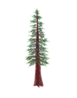
NORTH BAY LEAGUE REDWOOD DIVISION
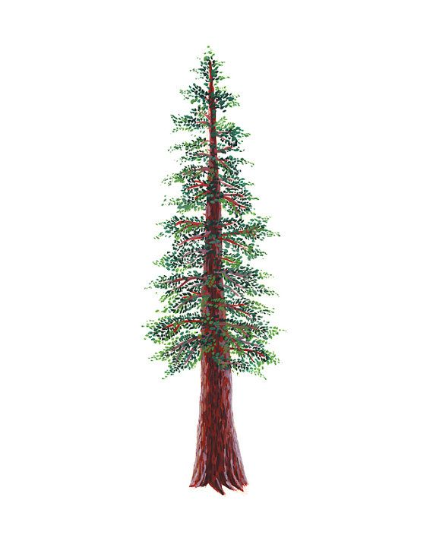
Swimming & Diving Schedule, 2023 – 2024
REVISED 10/6/23

Preseason Meeting: | TBD
First day of practice: | Monday, February 5
Number of contests: | 14 meets. Two (2) scrimmages are permissible prior to the first contest (league or non league) of the season. Each meet counts as one contest.
Meet time: | Ives: 3/3:30; Finley: 2/2:30; Ridgway, 2/2:30; Rancho, 2/2:30; Healdsburg, 3:30/4; Cardinal Newman, 3/3:30

WEDNESDAY, FEBRUARY 28 | TUESDAY, APRIL 2
Piner at Healdsburg (Healdsburg) | Analy bye
Analy bye | Rancho Cotate at Windsor (Healdsburg)
Rancho Cotate at Windsor(TBA) | WEDNESDAY, APRIL 3
 | Healdsburg at Piner (TBA)
TUESDAY, MARCH 5
Analy at Piner (TBA)
WEDNESDAY, MARCH 6 | THURSDAY, APRIL 4
Rancho Cotate at Healdsburg (TBA) | Rancho Cotate at Healdsburg
Windsor Bye | Piner at Analy (Ives)
 | Windsor bye
TUESDAY, MARCH 12 | TUESDAY, APRIL 9
Windsor at Healdsburg (Healdsburg) | Healdsburg at Windsor (Healdsburg)
Rancho Cotate at Analy (Ives) | Rancho Cotate at Analy (TBA)
Piner bye | Piner bye
WEDNESDAY, MARCH 13 | THURSDAY, APRIL 11
Windsor at Piner (TBA) | Rancho Cotate bye
THURSDAY, MARCH 14 | Piner at Windsor (Healdsburg)
Rancho Cotate bye | Healdsburg at Analy (Ives)
Analy at Healdsburg (Healdsburg)
WEDNESDAY, MARCH 27 | WEDNESDAY, APRIL 17
Analy at Windsor (Healdsburg) | Windsor at Analy (TBA)
Healdsburg bye | Healdsburg bye
THURSDAY, MARCH 28 | THURSDAY APRIL 18
Rancho Cotate at Piner (TBA) | Rancho Cotate at Piner (TBD)

NBL AND NCS CHAMPIONSHIP INFORMATION
TBA: | Santa Rosa Junior College High School Invitational
April 22: | Deadline for NBL meet qualifiers
April 24: | NBL Qualifying Championship seeding, 7 PM
April 26: | Championship prelims; warm-up, 11 – 11:45; start at 12 PM
April 27: | Championship finals; warm-up, 8 – 8:45; Meet starts at 9
April 27: | Deadline for leagues to determine qualifiers
April 27: | Final date for competition other than NCS Championships
April 28: | NCS entries due by 1:15 PM
April 29: | Seeding meeting
May 2: | *Diving Championship
May 3: | *Swimming trials
May 4: | Swimming Championships
May 9-11: | CIF State Championships
*When the venue for the swimming and diving championship allows both activities to be held in the same location, the diving championships will be held on the same day as the swimming trials.

