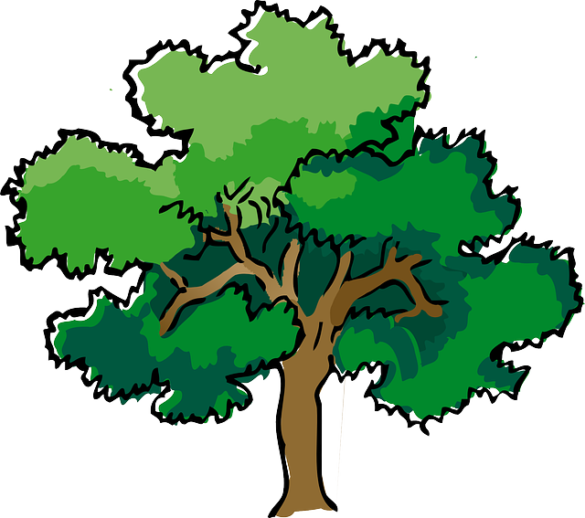
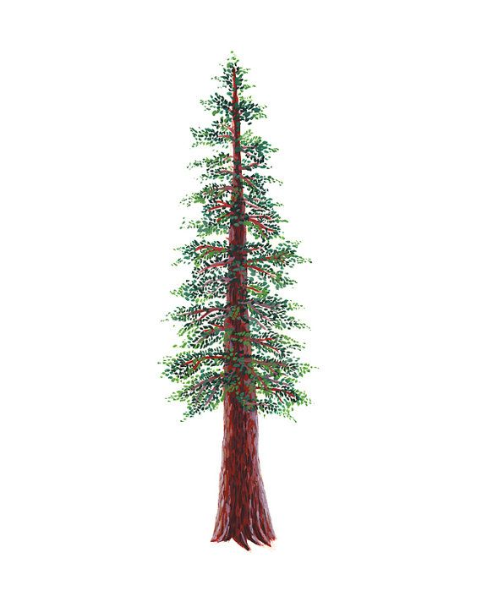
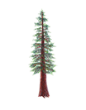
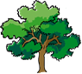
NORTH BAY LEAGUE
Track Schedule, 2022 – 2023

Revsied 10/25
Preseason coach meeting: | TBD
First day of practice: | Monday, February 6
Number of contests: | 14 contests. Two scrimmages are permissible prior to the first interscholastic contest (league or non-league) of the season.
Meet time: | 3:45 PM

OAK |  | REDWOOD
WEDNESDAY, MARCH 29  Montgomery at Maria Carrillo  Windsor at Santa Rosa  Analy bye |  | WEDNESDAY, MARCH 29  Ukiah at Piner  Rancho Cotate at Cardinal Newman  Elsie Allen at Healdsburg
WEDNESDAY, APRIL 5  Maria Carrillo at Santa Rosa  Analy at Windsor  Montgomery bye |  | WEDNESDAY, APRIL 5  Cardinal Newman at Ukiah  Rancho Cotate at Healdsburg  Elsie Allen at Piner
WEDNESDAY, APRIL 12  Santa Rosa at Montgomery  Maria Carrillo at Analy  Windsor bye |  | WEDNESDAY, APRIL 12  Cardinal Newman at Piner  Healdsburg at Ukiah  Elsie Allen at Rancho Cotate
WEDNESDAY, APRIL 19  Maria Carrillo bye  Montgomery at Windsor  Santa Rosa at Analy |  | WEDNESDAY, APRIL 19  Ukiah at Elsie Allen  Piner at Rancho Cotate  Cardinal Newman at Healdsburg
WEDNESDAY, APRIL 26  Analy at Montgomery  Santa Rosa bye  Windsor at Maria Carrillo |  | WEDNESDAY, APRIL 26  Piner at Healdsburg  Elsie Allen at Cardinal Newman  Rancho Cotate at Ukiah

IMPORTANT NBL, NCS AND CIF DATES
NBL Meet: Wednesday, May 3 and Friday, May 5 site and host TBD
Deadline for leagues to determine qualifiers: Saturday, May 6
Final date for competition other than NCS or CIF Championships: Saturday, May 6
Class A Classification Championships: May 13
Area Meets--Redwood Empire Meet: May 13
NCS Meet of Champions: May 19, 20
CIF State Track Championships: May 26-27

