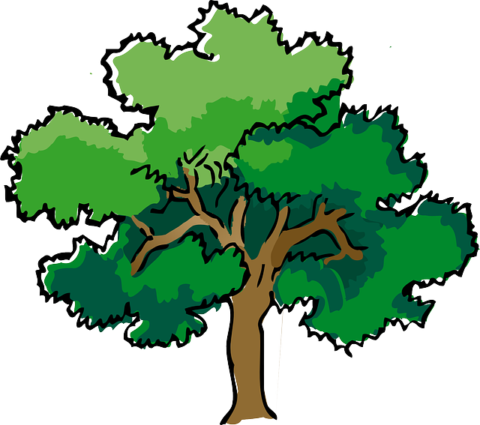
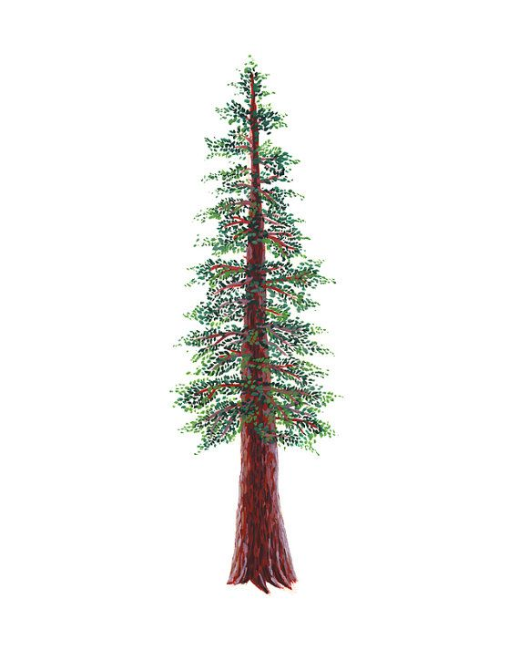
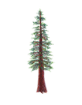
NORTH BAY LEAGUE
Track Schedule, 2023 – 2024

Revised 3/6/24
Preseason coach meeting: | TBD
First day of practice: | Monday, February 5
Number of contests: | 14 contests. Two scrimmages are permissible prior to the first interscholastic contest (league or non-league) of the season.
Meet time: | 4:00 PM

OAK |  | REDWOOD
WEDNESDAY, MARCH 27  Maria Carrillo at Montgomery  Santa vRosa at Windsor  Analy bye |  | WEDNESDAY, MARCH 27  Piner at Ukiah  Cardinal Newman at Rancho Cotate  Healdsburg Bye
WEDNESDAY, APRIL 3  Santa Rosa at Maria Carrillo  Windsor at Analy  Montgomery bye |  | WEDNESDAY, APRIL 3  Ukiah at Cardinal Newman  Rancho Cotate at Healdsburg  Piner Bye
WEDNESDAY, APRIL 10  Montgomery at Santa Rosa  Analy at Maria Carrillo  Windsor bye |  | WEDNESDAY, APRIL 10  Piner at Cardinal Newman  Ukiah at Healdsburg  Rancho Cotate Bye
WEDNESDAY, APRIL 17  Maria Carrillo bye  Windsor at Montgomery  Analy at Santa Rosa |  | WEDNESDAY, APRIL 17  Ukiah Bye  Rancho Cotate at Piner  Healdsburg at Cardinal Newman
WEDNESDAY, APRIL 24  Montgomery at Analy  Santa Rosa bye  Maria Carrillo at Windsor |  | WEDNESDAY, APRIL 24  Healdsburg at Piner  Cardinal Newman Bye  Ukiah at Rancho Cotate

IMPORTANT NBL, NCS AND CIF DATES
NBL Meet: Tuesday, April 30 and Thursday, May 2 site Santa Rosa
Deadline for leagues to determine qualifiers: Saturday, May 4
Final date for competition other than NCS or CIF Championships: Saturday, May 4
Class A Classification Championships: May 11
Area Meets--Redwood Empire Meet: May 11
NCS Meet of Champions: May 17, 18
CIF State Track Championships: May 24-25

