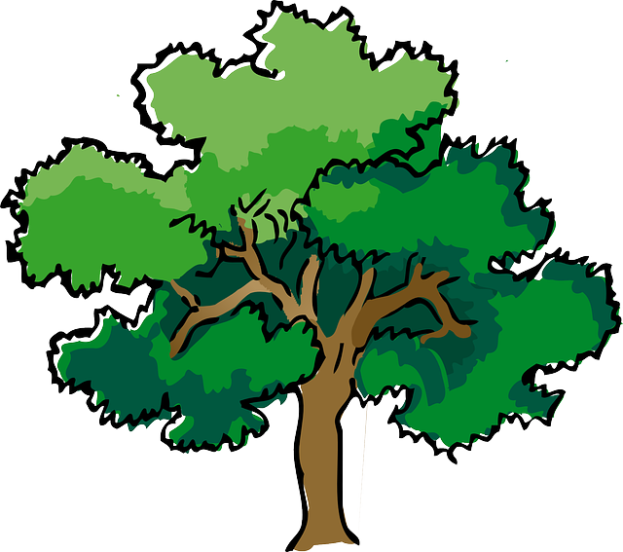
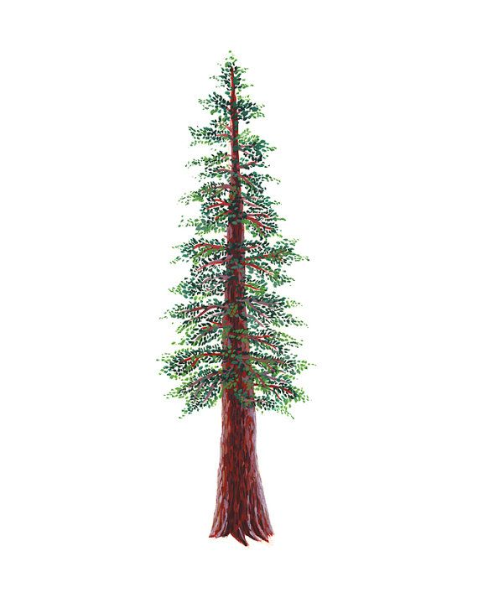
NORTH BAY LEAGUE
Track Schedule, 2021 – 2022
REVISED 3/7/22 TO REFLECT PROPER REVERSAL OF
HOME SITES and EAHS having all away meets FROM THE 2020-2021 SEASON

Preseason coach meeting: | Monday, January 31, site and time TBD
First day of practice: | Monday, February 7
Number of contests: | 14 contests. Two scrimmages are permissible prior to the first interscholastic contest (league or non-league) of the season.
Meet time: | 3:45 PM

OAK
WEDNESDAY, MARCH 30  Santa Rosa at West County  Maria Carrillo at Windsor  Piner at Montgomery |  | WEDNESDAY, APRIL 6  Ukiah at Newman  Elsie & Rancho at Healdsburg
WEDNESDAY, APRIL 6  Santa Rosa at Windsor  Maria Carrillo at Montgomery  West County at Piner |  | WEDNESDAY, APRIL 13  Elsie & Newman at Healdsburg  Ukiah at Rancho Cotate
WEDNESDAY, APRIL 13  Windsor at West County  Montgomery at Santa Rosa  Maria Carrillo at Piner |  | WEDNESDAY, APRIL 20  Newman at Rancho  Elsie & Healdsburg at Ukiah
WEDNESDAY, APRIL 20  Piner at Santa Rosa  West County at Maria Carrillo  Windsor at Montgomery |  | WEDNESDAY, APRIL 27  CN, EH, HHS, RCHS at Ukiah
WEDNESDAY, APRIL 27  Montgomery at West County  Windsor at Piner  Santa Rosa at Maria Carrillo |  | NBL Meet: Wednesday, May 4 and Friday, May 6; site and host Piner

IMPORTANT NBL, NCS AND CIF DATES
NBL Meet: Wednesday, May 4 and Friday, May 6; site and host Piner
Deadline for leagues to determine qualifiers: May 7
Final date for competition other than NCS or CIF Championships: May 7
Class A Classification Championships: May 14
Area Meets--Redwood Empire Meet: May 14
NCS Meet of Champions: May 20, 21
CIF State Track Championships: May 27, 28

SCHOOL | HOME | AWAY |  | SCHOOL | HOME | AWAY
MCHS | 2 | 3 |  | CNHS | 2 | 3
MHS | 3 | 2 |  | HHS | 3 | 2
PHS | 3 | 2 |  | EAHS | 3 | 2
SRHS | 2 | 3 |  | RCHS | 3 | 2
WCHS | 3 | 2 |  | SVHS | 2 | 3
WHS | 2 | 3 |  | UHS | 2 | 3

