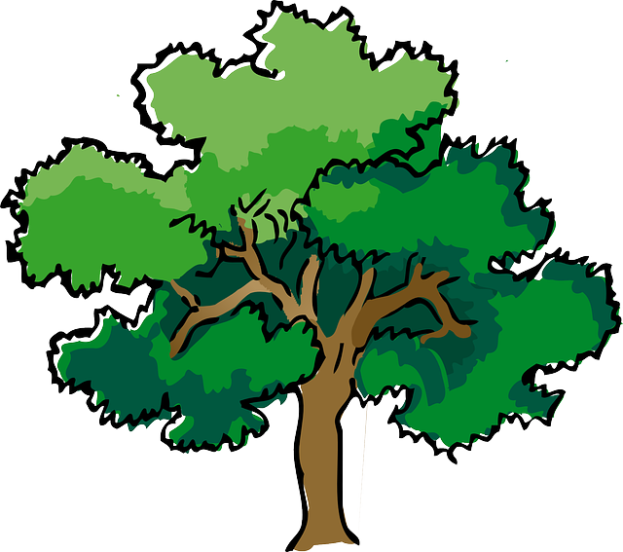
NORTH BAY LEAGUE OAK DIVISION
Volleyball Schedule 2023 – 2024

Preseason coaches’ meeting: | Thursday, August ??, CNHS ACC, 5 PM
First day of practice | Monday, August 7, 2023
Number of contests: | 24 matches and two scrimmages
Post season/all-league selection meeting: | Monday, October 23, 6:30 PM, site TBD
Tournaments | Each day of a tournament counts as 2 matches unless only one match is played
Match start time: | JV: 5 PM, Varsity immediately after; Ukiah matches begin at 4:30 with varsity immediately after

TUESDAY, SEPTEMBER 19 |  |  | THURSDAY, OCTOBER 5
 | Santa Rosa at Windsor |  |  | Windsor at Santa Rosa
 | Maria Carrillo at Montgomery |  |  | Montgomery at Maria Carrillo
 | Analy at Cardinal Newman |  |  | Cardinal Newman at Analy
THURSDAY, SEPTEMBER 21 |  |  | TUESDAY, OCTOBER 10
 | Montgomery at Santa Rosa |  |  | Santa Rosa at Montgomery
 | Cardinal Newman at Maria Carrillo |  |  | Maria Carrillo at Cardinal Newman
 | Windsor at Analy |  |  | Analy at Windsor
TUESDAY, SEPTEMBER 26 |  |  | THURSDAY, OCTOBER 12
 | Windsor at Montgomery |  |  | Montgomery at Windsor
 | Santa Rosa at Cardinal Newman |  |  | Cardinal Newman at Santa Rosa
 | Analy at Maria Carrillo |  |  | Maria Carrillo at Analy
THURSDAY, SEPTEMBER 28 |  |  | TUESDAY, OCTOBER 17
 | Analy at Santa Rosa |  |  | Santa Rosa at Analy
 | Maria Carrillo at Windsor |  |  | Windsor at Maria Carrillo
 | Cardinal Newman at Montgomery |  |  | Montgomery at Cardinal Newman
TUESDAY, OCTOBER 3 |  |  | THURSDAY, OCTOBER 19
 | Cardinal Newman at Windsor |  |  | Windsor at Cardinal Newman
 | Montgomery at Analy |  |  | Analy at Montgomery
 | Santa Rosa at Maria Carrillo |  |  | Maria Carrillo at Santa Rosa

NCS/Les Schwab Tires Championships
Final date for leagues to determine qualifiers: October 21
Final date for competition other than NCS or CIF Championships: October 21
NCS postseason applications due (automatic & at-large): October 21, 10 PM
NCS At Large meeting: October 22 (Coaches do not attend)
NCS Championships, Divisions 1, 3, 5: October 24, 28; November 1, 4
NCS Championships, Divisions 2, 4, 6: October 25, 28; November 1, 4
CIF Nor-Cal Championships: November 7, 8, 9, 11, 14
CIF State Championship: November 17 - 18

