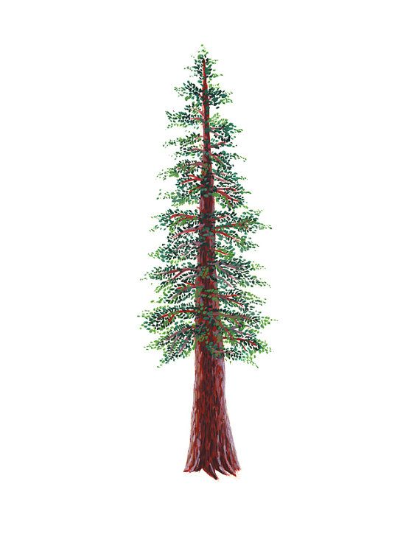
NORTH BAY LEAGUE REDWOOD DIVISION
Volleyball Schedule 2023 – 2024

Preseason coaches’ meeting: | Thursday, August ??, CNHS ACC, 5 PM
First day of practice | Monday, August 7
Number of contests: | 24 matches and two scrimmages
Post season/all-league selection meeting: | Monday, October 23, 6:30 PM, site TBD
Tournaments | Each day of a tournament counts as 2 matches unless only one match is played
Match start time: | JV: 5 PM, Varsity immediately after.  Ukiah matches begin at 4:30, immediately after.

TUESDAY, SEPTEMBER 19 |  |  | THURSDAY, OCTOBER 5
 | Elsie Allen at Ukiah |  |  | Ukiah at Elsie Allen
 | Healdsburg at Piner |  |  | Piner at Healdsburg
 | St. Vincent at Rancho Cotate |  |  | Rancho Cotate at St. Vincent
THURSDAY, SEPTEMBER 21 |  |  | TUESDAY, OCTOBER 10
 | Piner at Elsie Allen |  |  | Elsie Allen at Piner
 | Rancho Cotate at Healdsburg |  |  | Healdsburg at Rancho Cotate
 | Ukiah at St. Vincent |  |  | St. Vincent at Ukiah
TUESDAY, SEPTEMBER 26 |  |  | THURSDAY, OCTOBER 12
 | Ukiah at Piner |  |  | Piner at Ukiah
 | Elsie Allen at Rancho Cotate |  |  | Rancho Cotate at Elsie Allen
 | St. Vincent at Healdsburg |  |  | Healdsburg at St. Vincent
THURSDAY, SEPTEMBER 28 |  |  | TUESDAY, OCTOBER 17
 | St. Vincent at Elsie Allen |  |  | Elsie Allen at St. Vincent
 | Healdsburg at Ukiah |  |  | Ukiah at Healdsburg
 | Rancho Cotate at Piner at Rancho |  |  | Piner at Rancho Cotate
TUESDAY, OCTOBER 3 |  |  | THURSAY, OCTOBER 19
 | Rancho Cotate at Ukiah |  |  | Ukiah at Rancho Cotate
 | Piner at St. Vincent |  |  | St. Vincent at Piner
 | Elsie Allen at Healdsburg |  |  | Healdsburg at Elsie Allen

NCS/Les Schwab Tires Championships
Final date for leagues to determine qualifiers: October 21
Final date for competition other than NCS or CIF Championships: October 21
NCS postseason applications due (automatic & at-large): October 21, 10 PM
NCS At Large meeting: October 22 (Coaches do not attend)
NCS Championships, Divisions 1, 3, 5: October 24, 28; November 1, 4
NCS Championships, Divisions 2, 4, 6: October 25, 28; November 1, 4
CIF Nor-Cal Championships: November 7, 8, 9, 11, 14
CIF State Championship: November 17 - 18

