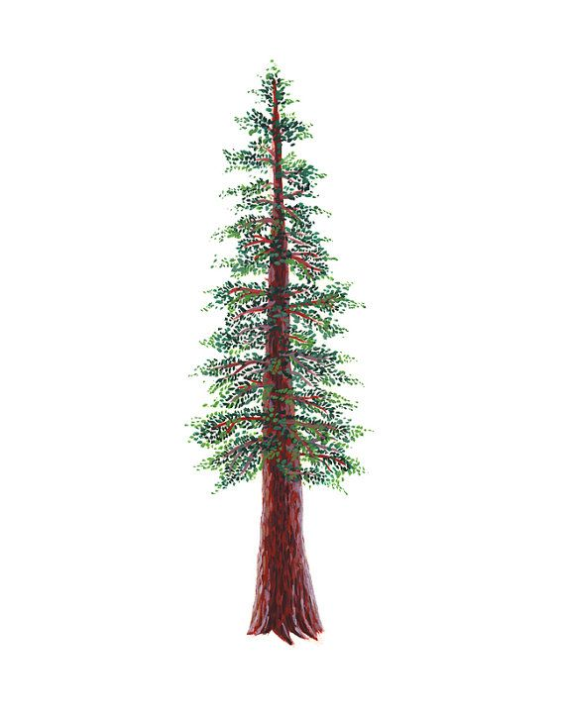
NORTH BAY LEAGUE REDWOOD DIVISION
Volleyball Schedule 2024 – 2025
Revised 4/2/24
(Year 1 of a two-year rotation)
Preseason coaches’ meeting: | Thursday, August TBA, CNHS ACC, 5 PM
First day of practice | Monday, August 12
Number of contests: | 24 matches and two scrimmages
Post season/all-league selection meeting: | Monday, October TBA, 6:30 PM, site TBD
Tournaments | Each day of a tournament counts as 2 matches unless only one match is played
Match start time: | JV: 5 PM, Varsity immediately after.  Ukiah matches begin at 4:30, immediately after.

TUESDAY, SEPTEMBER 24 |  |  | THURSDAY, OCTOBER 10
 | St. Vincent at Elsie Allen |  |  | Elsie Allen at St. Vincent
 | Healdsburg at Rancho Cotate |  |  | Rancho Cotate at Healdsburg
 | Piner at Analy |  |  | Analy at Piner
THURSDAY, SEPTEMBER 26 |  |  | TUESDAY, OCTOBER 15
 | Elsie Allen at Healdsburg |  |  | Healdsburg at Elsie Allen
 | Rancho Cotate at Piner |  |  | Piner at Rancho Cotate
 | Analy at St. Vincent |  |  | St. Vincent at Analy
TUESDAY, OCTOBER 1 |  |  | THURSDAY, OCTOBER 17
 | Healdsburg at St. Vincent |  |  | St. Vincent at Healdsburg
 | Piner at Elsie Allen |  |  | Elsie Allen at Piner
 | Rancho Cotate at Analy |  |  | Analy at Rancho Cotate
THURSDAY, OCTOBER 3 |  |  | TUESDAY, OCTOBER 22
 | Elsie Allen at Analy |  |  | Analy at Elsie Allen
 | St. Vincent at Rancho Cotate |  |  | Rancho Cotate at St. Vincent
 | Healdsburg at Piner |  |  | Piner at Healdsburg
TUESDAY, OCTOBER 8 |  |  | THURSDAY, OCTOBER 24
 | Piner at St. Vincent |  |  | St. Vincent at Piner
 | Analy at Healdsburg |  |  | Healdsburg at Analy
 | Rancho Cotate at Elsie Allen |  |  | Elsie Allen at Rancho Cotate
NCS/Les Schwab Tires Championships
Final date for leagues to determine qualifiers: October 26
Final date for competition other than NCS or CIF Championships: October 26
NCS postseason applications due (automatic & at-large): October 26, 10 PM
NCS At Large meeting: October 27 (Coaches do not attend)
NCS Championships, Divisions 1, 3, 5: October 29, November 2, 6 and 9
NCS Championships, Divisions 2, 4, 6: October 30, November 2, 6 and 9
CIF Nor-Cal Championships: November 12, 13, 14, 16, 19
CIF State Championship: November 22 - 23

